

STUDENT HAND BOOK
BACHELOR OF TECHNOLOGY

SEMESTER-3rd
STUDY SCHEME-2011

DEPARTMENT OF CIVIL ENGINEERING
ASRA COLLEGE OF ENGINEERING & TECHNOLOGY, BHAWANIGARH

STUDY SCHEME
3rd Semester Contacts Hours: 33 Hrs

Course Code | Course Name | Load Allocation |  |  | Marks Distribution |  | Total  Marks | credits
Course Code | Course Name | L | T | P | Internal | External | Total  Marks | credits
BTAM-301 | Engineering Mathematics-III* | 4 | 1 | - | 40 | 60 | 100 | 5
BTCE-301 | Fluid Mechanics-I | 3 | 1 | - | 40 | 60 | 100 | 4
BTCE-302 | Rock Mechanics &Engg .Geology | 3 | 1 | - | 40 | 60 | 100 | 4
BTCE-303 | Strength of Materials | 3 | 2 | - | 40 | 60 | 100 | 4
BTCE-304 | Surveying | 3 | 1 | - | 40 | 60 | 100 | 4
BTCE-305 | Building Materials &  Construction | 4 | 0 | - | 40 | 60 | 100 | 4
BTCE-306 | Fluid Mechanics-I Lab | - | - | 2 | 30 | 20 | 50 | 1
BTCE-307 | Strength of Materials Lab | - | - | 2 | 30 | 20 | 50 | 1
BTCE-308 | Surveying Lab | - | - | 3 | 30 | 20 | 50 | 2
BTCE-309 | Workshop Training of 4 weeks duration after  2nd semester Carpentry, Electrical, Plumbing,  Masonry, CAD |  |  |  | 30 | 20 | 50 | 1
Total |  | 20 | 06 | 07 | 360 | 440 | 800 | 31

AUTHORS-
Prof. Sandeep Sharma
Er. Navjot Inder Singh

DEPARTMENT OF CIVIL ENGINEERING

DEPARTMENT TEACHERS
Srno. | Name of Teacher | Contact no. | Email-id
1. | Prof. Sandeep Sharma | 9592800327 | asrahodme@gmail.com
2. | Er. Navjot Inder Singh | 9780909343 | asramef2@gmail.com
3. | Er. Anuradha | 7837402841 | rajpootsanjana5@gmail.com
4. | Er. NirajBala | 9463626838 | asracivilf5@gmail.com
5. | Er. Kulwinder Singh | 9041777830 | asracivilf7@gmail.com
6. | Er. Kailash K. Garg | 9023542029 | asracivilf11@gmail.com
7. | Er. Aman Kumar | 7837989825 | er.amankumar25@gmail.com
8. | Er. Sandeep Singh | 9803836342 | Sohi.ss84@gmail.com

SUBJECT TEACHERS 3rd SEMESTER
Srno. | Name of Subject | Subject code | Subject Teachers Name | Department
1 | Engineering Mathematics-III* | BTAM-301 | Miss Dimple Chawla | Applied Science
2 | Fluid Mechanics-I | BTCE-301 | Er. Jagdeep Singh | Mechanical Engg.
3 | Rock Mechanics &Engg .Geology | BTCE-302 | Er. Niraj Bala | Civil Engineering
4 | Strength of Materials | BTCE-303 | Er. Omesh Jindal | Mechanical Engg.
5 | Surveying | BTCE-304 | Er. Aman Kumar | Civil Engineering
6 | Building Materials &  Construction | BTCE-305 | Er. Anuradha | Civil Engineering
7 | Fluid Mechanics-I Lab | BTCE-306 | Er. Jagdeep Singh | Mechanical Engg.
8 | Strength of Materials Lab | BTCE-307 | Er. Omesh jindal | Civil Engineering
9 | Surveying Lab | BTCE-308 | Er. Aman Kumar | Civil Engineering

PTU SYLLABUS

BTAM 301 ENGINEERING MATHEMATICS-III

Unit I Fourier series: Periodic functions, Euler's formula. Even and odd functions, half range expansions,Fourier series of different wave forms.

Unit II Laplace Transforms: Laplace transforms of various standard functions, properties of Laplace
Transforms, inverse Laplace transforms, transform of derivatives and integrals, Laplace transform of unit step
Function, impulse function, periodic functions, applications to solution of ordinary linear differential equations
with constant coefficients, and simultaneous differential equations.

Unit III Special Functions: Power series solution. of differential equations, Frobenius method, Legendre's equation,Legendre polynomial, Bessel's equation, Bessel functions of the first and second kind. Recurrence relations, equations reducible to Bessel's equation.

Unit IV Partial Differential Equations: Formation of partial differential equations, Linear partial differential equations,homogeneous partial differential equations with constant coefficients.

Unit V Applications of PDEs: Wave equation and Heat conduction equation in one dimension. Two Dimensional Laplace equation in Cartesian Coordinates, solution by the method of separation of variables..

Unit VI Functions of Complex Variable: Limits, continuity and derivative of the function of complex variable,Analytic function, Cauchy-Riemann equations, conjugate functions, harmonic functions; Conformal Mapping:Definition, standard transformations, translation, rotation, inversion, bilinear. Complex Integration: Lineintegrals in the complex plane, Cauchy's theorem, Cauchy's integral formula and derivatives of analytic function.Taylor's and Laurent's expansions (without proofs), singular points, poles, residue, Integration of function ofcomplex variables using the method of residues.

Suggested Readings/ Books:
• Kreyszing, E., Advanced Engineering Mathematics, Eighth edition, John Wiley, New Delhi.
• Grewal, B. S., Higher Engineering Mathematics, KhannaPublishers, New Delhi.
• Ian N. Sneedon, Elements of Partial Differential Equations, McGraw- Hill, Singapore, 1957.
• Peter. V. O'Nil, Advanced Engineering Mathematics, Wadsworth Publishing Company.
• Taneja, H. C., Engineering Mathematics, Volume-I & Volume-II, I. K. Publisher.
• Babu Ram, Advance Engineering Mathematics, Pearson Education.
• Bindra, J. S., Applied Mathematics, Volume-III, Kataria Publications.
• Advanced Engineering Mathematics, O'Neil, Cengage Learning.

ASSIGNMENTS

ENGINEERING MATHEMATICS-III

Assignment-1

Date of allotment: Date of submission:

Topic: Laplace transform

- Find the Laplace transform of the following:
- √t
- e^{t}sin2 t
- sin²h(t)
- Cosh (at).cos(at)
- cost.cos2t
- Sin(3t + 2)
- 2t²- 6t + 8
- Using the shifting theorem, calculate the Laplace transforms of the functions:
    - e^{ax}sinh(kx)
    - e^{ax}cosh(kx)
    - Cosh(x) sin(x)
    - [e^{4t}(t²+ 3t + 5)].
- Find the Laplace transform of$\frac{\cos{at}–\cos{bt}}{t}$ .
- Determine the inverse Laplace transform of$\frac{12}{s^{2}\left(s + 2\right)}$

- Determine the inverse Laplace transform of$\frac{s}{s^{4}+a^{4}}$.

- Determine the inverse Laplace transform of$\frac{3s+1}{{(s+1)}^{2}}$

- State and prove convolution theorem.
- Find the inverse of the equation by convolution theorem (s+2)/ (s²+4s+5)².
- Solve the differential equation $x’’-3x’+2x$=1-e^{2t}; $x$ (0) = 1,$x’$ (0) = 0.
- Solve the differential equation $y’’+y’-2y$=t; $y$ (0) = 1, $y’$ (0) = 0.
- Use Laplace transforms technique to solve the initial value problem
- $y’’-$4y = e^{3t}, y (0) = 0,$y’$(0) = 0.

Assignment-2

Date of allotment: Date of submission:

Topic: Fourier series

- Find the Fourier series of f(x) = x+x² in the interval –π < x < π.
- Find the Fourier series of sine terms only if f(x) = x in the interval 0 < x < π.
- Find the Fourier series of cosines terms only f(x) = π-x in the interval 0 < x < π.
- Find the Fourier series of f(x) =e^{ax}in the interval –π < x < π.
- Write down the Fourier series of Square Wave Form
- Find the Fourier series of modified Saw Toothed Wave Form.
- Find the Fourier series of Full Wave Rectifier Form.
- Obtain the Fourier series for the triangular wave form.
- Find the half range cosine form for the function f(x) =(x-π) ² in the interval 0 < x <π .
- Find the Fourier series of f(x) = cosx, −π < x ≤ π.
- Expand f(x) = xsinx ,0< x < 2π in Fourier series.
- Derive Euler’s formulae.

Assignment-3

Date of allotment: Date of submission:

Topic: Partial Differential Equation & Applications OfPde

Solve the following equation:-
- (x²-y²-z²)p+2xyq=2xz
- px-qy=y²-x²
- p+q=sin x+sin y
- p²=zq
- z=p²x+q²y(by Charpit’s method)
- Solve (D+2D’)(D-3D’)²z=0
7.$\frac{∂^{4}z}{{∂x}^{4}}+ \frac{∂^{4}z}{{∂y}^{4}}=\frac{2∂^{4}z}{{∂x}^{2}{∂y}^{2}}$
- Solve r+2s+t=2(y-x)+sin(x-y)
- (D²-6DD’+9D’²)z=12x²+36xy
- Write the wave equation to find solution and solve a problem.
- Write the solution of heat equation and solve a problem.
- Write the solution of laplace equation and solve a problem.
- A bar 10 cm long, with insulated sides, has its ends a and b maintained a temperature 50 c resp. Until steady state conditions prevails. The temperature at a is suddenly raised at 90 c at the same time at b is lowered to 60 c. Find the temperature distribution in the bar at time t.

Assignment-4

Date of allotment: Date of submission:

Topic: Functions of Complex Variable

- Define analytic function. Write necessary and sufficient condition for a given function to be analytic.
- Define harmonic function.
- Show that the function h(x,y)=3x²y-y³+4 is harmonic and find its harmonic Conjugate.
- Show that the function coshz is analytic and find its derivative.
- State Cauchy integral theorem.
- State and prove Cauchy integral formula and
- Evaluate $\oint{(sinπz^{2}}+cosπz^{2})/\{\left(z-1\right)\left(z-2\right)\}$dz.
- Evaluate $\int{\frac{e^{-z}}{{\left(z+1\right)}^{3}}}$dx, where C is the ׀z׀=2.
- Evaluate $\oint_{c}{\frac{z^{2}-z-1}{z-1}}dz$, where C is the ׀z׀=1/2.
- Evaluate $\oint{\frac{z-1}{{\left(z+1\right)}^{2}\left(z-2\right)}}$dz where C is the ׀z-i׀=2.
- Find $\int_{0}^{1+i}{(x-y+ix^{2}})$dz along the straight line from z=0 to z= 1+i.
- Define singularity and write types of singularity with example.
- Define poles and zeros of a function f(z) with example.
- State Cauchy Residue Theorem and determine poles and residue at each pole of the function f(z) = $\frac{z^{2}}{{\left(z+1\right)}^{2}(z-2)}$ and evaluate $\oint_{c}{f\left(z\right)dz}$ , where C: ׀z׀=5/2.
- Find the residue of f(z) = cosec²z at z=0.
- Define order of zero and further find the zeros of the function F(z)= z tan²z . Also find the order of the zeros.
- State Taylor series and Laurent series.
- Discuss the nature of the singularity of f(z) = $\frac{z-sinz}{z^{3}}$ at z = 0
- Using Contour Integration, prove that $\int_{-∞}^{∞}{\frac{dx}{{(1+x^{2})}^{2}}}$= $\frac{π}{2}$ . Hence evaluate $\int_{0}^{∞}{\frac{dx}{{(1+x^{2})}^{2}}}$
- Expand the function in Laurent’s series f(z) = $\frac{e^{z}}{{(z-1)}^{2}}$ about z = 1.
- Expand the function f(z) = $\frac{1}{\left(z+1\right)(z+3)}$ in the regions 1$<׀z׀<$3.

Assignment-5

Date of allotment: Date of submission:

Topic: Special Functions
- Evaluate ∫J₅(x) dx
- Prove that d/dxJ_{n}(x) = n/x J_{n}(x) – J_{n+1}(x).
- J_{-1/2}(x) = √2/πx cosx.
- Define orthogonality of Bessel Function.
- Define Error Function and also its properties.
- Show that : (a) erf 0= 0 , (b) erf_{c} 0 = 1 , (c) erf ∞ =1 , (d) erf_{c}∞ = 0.
- Prove that erf(-x) = - erf(x).
- write the singular points of the differential equation:x³(x-1)y"+2(x-1)y'+y=0
- Prove that: J_{-n}(x) = (-1)^{n}J_{n}(x).
- Prove that: 2J_{n}(x) = J_{n-1}(x)- J_{n+1}(x)

BTCE301 FLUID MECHANICS-I

- FLUID AND THEIR PROPERTIES :

Concept of fluid, difference between solids, liquids and gases; ideal and real fluids; Continuum concept of fluid: density, specific weight and relative density; viscosity and its dependence on temperature; surface tension and capillarity, vapor pressure and cavitation, compressibility band bulk modulus; Newtonian and non-Newtonian fluids.

- FLUID STATICS :

Concept of pressure, Pascal’s law and its engineering hydrostatic paradox. Action of fluid pressure on plane (horizontal, vertical and inclined) submerged surface, resultant force and center of pressure , force on a curved surface due to hydrostatic pressure. Buoyancy and flotation, stability of floating and submerged bodies, Meta centric height and its determination.

- FLUID KINEMATICS:

Classification of fluid flows, velocity and acceleration of fluid particle, local and convective acceleration, normal & tangential acceleration streamline, pathline and streakline, flow rate and Rotational velocity and circulation, stream & velocity potential functions.

- FLUID DYNAMICS :

Euler’s equation, Bernoulli’s equation and steady flow energy equation; representation of energy changes in fluid system, impulse momentum equation, kinetic energy and momentum correction factors, flow along a curved streamline, free and forced vortex motions.

- DIMENSIONAL ANALYSIS AND SIMILITUDE:

Fundamental and derived units and dimensions, dimensional homogeneity, Rayleigh’s and Buckingham’s Pi method for dimensional analysis, dimension less number and their significance, geometric, kinematic and dynamic similarity, model studies.

- FLOW PAST IMMERSED BODIES:

Drag and lift deformation Drag and pressure drag. Drag on a sphere,cylinder and Airfoil: lift-Magnus Effect and circulation, lift on a circular cylinder.

- FLOW MEASUREMENT:-

Manometers, Pitot tubes, venturimeter and orifice meters, orifices, mouth pieces, notches ( Rectangular and V-notches) and weirs ( Sharp crested Weirs).

SUGGESTED READINGS / BOOKS:

- Fluid Mechanics & Hydraulic Machines : Dr. R.K. Bansal
- Hydraulic and Fluid Mechanic by P.N.Modi&S.M.Seth
- Engineering Fluid Mechanics by R.J.Garde&A.G.Mirajgaoker
- Fluid Mechanics by Douglas JF, Gasiorek JM, Swaffield JP; Pitman
- Fluid Mechanics :Streetes VL & Wylie EB; Mcgraw Hill book company.
- Fluid Mechanics by White
- Introduction to Fluid Mechanics by Robert W.Fox& Alan T.McDonald
- Fluid Mechanics by Potter, Cengage Learning

Assignments

FLUID MECHANICS-I

Assignment #1
- What is the concept of fluid?
- Differentiate between solids, liquids and gases.
- What do you understand from surface tension and capillarity?
- What is compressibility band bulk modulus?
- Differentiate between Newtonian and non-Newtonian fluids.

Assignment #2

- What is Pascal’s law? What do you understand from engineering hydrostatic paradox?
- What do you understand from resultant force and center of pressure?
- Explain force on a curved surface due to hydrostatic pressure?
- What is Meta centric height and its determination?
- What is stability of floating and submerged bodies?

Assignment #3

- What is the Classification of fluid flows?
- What is impulse momentum equation?
- Explain normal & tangential acceleration streamline.
- Explain flow rate and discharge mean velocity continuity equation in Cartesian co-ordinates?
- What is a free and forced vortex motion?

Assignment #4

- What is Fundamental and derived units and dimensions?
- Explain Rayleigh’s and Buckingham’s Pi method for dimensional analysis.
- Explain kinematic and dynamic similarity.
- What do you understand from dimension less number and their significance?

Assignment #5

- What do you understand from Drag and pressure drag?
- Explain briefly orifices? And differentiate between venturimeter and orifice meters.
- What are notches? Explain Rectangular and V-notches.
- What do you understand from weirs? Also explain Sharp crested Weirs.

BTCE302 ROCK MECHANICS & ENGINEERING GEOLOGY

- GENERAL GEOLOGY :

Importance of Engg. Geology applied to Civil Engg. Practices.Weathering,definition, types and effect. Geological works of rivers, wind, glaciers as agents of erosion,transportation and deposition.

- ROCKS & MINERALS :

Minerals, their identification, igneous, sedimentary & metamorphic rocks.Classification of rocks for engineering purposes.Rock quality designation (RQD).

- STRUCTURAL GEOLOGY:

Brief idea about stratification, apparent dip, true dip, strike and inconformities. Folds, faults &joints : definition, classification relation to engineering operations.

- ENGINEERING GEOLOGY:

Geological considerations in the Engg. Projects like tunnels, highways,foundation, dams, reservoirs. Earthquake : Definition, terminology, earthquake waves, intensity,recording of earthquake.

- ENGINEERING PROPERTIES OF ROCKS AND LABORATORY MEASUREMENT :

Uniaxial compression test,tensile tests, permeability test, shear tests, size and shape of specimen rate of testing. Confiningpressure, stress strain curves of typical rocks. Strength of intact and fissured rocks, effect ofanisotropy, effect of saturation and temperature

- IN-SITU DETERMINATION OF ENGG. PROPERTIES OF ROCK MASSES :

Necessity of in-situ tests, uniaxialload tests in tunnels and open excavations, cable tests, flat jack test, shear test, pressure tunneltest. Simple methods of determining in situ stresses,bore hole test

- IMPROVEMENT IN PROPERTIES OF ROCK MASSES :

Pressure grouting for dams and tunnels,rock reinforcement rock bolting.

SUGGESTED READINGS / BOOKS:

- Introduction to Rock Mechanics : Richard E. Goodman.
- Engg. Behaviour of rocks :Farmar, I.W.
- Rock Mechanics and Engg. : Jaager C.
- Fundamentals of Rock Mechanics : Jaager and Cook
- Engineering Geology : D.S.Arora
- Engineering Geology : Parbin Singh
- Rock Mechanics for Engineering : B.P. Verma.

ASSIGNMENTS
ROCK MECHANICS & ENGINEERING GEOLOGY

ASSIGNMENT -1
- What is the importance of geology in civil engineering?
- What do you understand by rock? Explain classification of rocks?
- Describe briefly the natural agencies of which are responsible for the weathering of rocks?
- Explain briefly the geological works of rivers?
- Define minerals and explain briefly physical properties of minerals?

ASSIGNMENT -2
- Define faults? Explain briefly the classification of faults?
- Write a note on RQD ( Rock quality Designation ) ?
- Define the following terms:-
- Dip and Strike
- Outliers and Inliers
- Intensity of earthquakes
- Seismograph
- Isoclinal folds
- What are unconformities? Explain its formation and types of unconformities?
- Explain the geological investigation and various geological factors which influence the making of roads

ASSIGNMENT -3
- Explain briefly the geological investigation of tunnel site?
- Define earthquake waves? Explain its types?
- Explain the joints in igneous , sedimentary , and metamorphic rocks?
- Define the following terms:-
- Fault Plane
- Barchans
- Magnitude of earthquake
- Deformability
- Explain briefly the geological investigation of a dam site?
- Explain the uniaxial compression test?

ASSIGNMENT -4
- Explain briefly the stress strain curves of typical rocks?
- Describe in detail the effect of saturation upon rock strength?
- Write a note on Necessity of insitu tests?
- Explain briefly method for field deformability determination using a plate test down a borehole?
- Describe the effect of confining pressure on rocks?

ASSIGNMENT -5
- Define the term grouting? Explain objects of grouting and methods of grouting?
- Define rock bolting? Explain the various types of rock bolts?
- Explain flat jack test for determining properties of rock masses in insitu conditions?
- Explain briefly any two type methods of determining in situ stresses?
- Write a note on following terms:-
- Rock Anchors
- Rock Reinforcement

BTCE 303 STRENGTH OF MATERIAL

- CONCEPT OF EQUILIBRIUM:

Load, reaction; General equilibrium equations; Equilibrium of a pointin space; Equilibrium of a member; Concept of free body diagrams; Displacements; Concept ofdisplacement-constraints/ supports; Statical-determinacy of a problem.

- SIMPLE STRESS AND STRAINS:

Introduction; Concept of stress and strain; Stress-strain curves forductile, brittle materials; Generalized Hooke’s law, Stress-strain diagram of ductile and brittlematerial, statically determinate and indeterminate problems, compound and composite bars,thermal stresses. Elastic constants, relations between various elastic constants and its use;Lateral strain, volumetric strain, poisons ratio; Stress and strains in thin cylinders, sphericalshells; Thin vassals subjected to internal pressures.

- COMPLEX STRESS AND STRAINS:

Introduction; Normal stress, tangential stress; Rectangular blocksubjected to normal stress along and across two planes, combination of normal and tangentialstress; Concept of principal stress and its computation; Mohr circle; Principal strains,computation of principal stresses from the principal strains.

- SHEAR FORCE AND BENDING MOMENT DIAGRAMS:

Introduction to the concept of reactiondiagrams—shear force and bending moment; Role of sign conventions; Types of load, beams,supports; Shear force and bending moment diagrams: simply supported, overhang and cantileverbeams subjected to any combination of point loads, uniformly distributed and varying load, andmoment; Relationship between load, shear force and bending moment; Different methods forplotting a bending moment and shear force diagrams.

- BENDING AND SHEAR STRESSES:

Introduction; Assumptions and derivation of flexural formula forstraight beams; Centroid of simple and built up section, second moment of area; Bending stresscalculation for beams of simple and built up section, composite sections (flitched sections);Shear stress; Variation of bending and shear stress along the depth of section.

- COLUMNS AND STRUTS:

Stability of Columns; Buckling load of an axially loaded columns withvarious end conditions; Euler’s and Rankine’s formula; Columns under eccentric load, lateralload.

- TORSION OF CIRCULAR SHAFTS:

Torsion, basic assumptions, derivation of torsion equation; Powertransmitted by shafts; analysis and design of solid and Hollow shafts based on strength andstiffness; Sections under combined bending and torsion, equivalent bending and torsion.

- FAILURE THEORIES:

Maximum principal stress theory, Maximum shear stress theory, DistortionEnergy theory, Strain Energy theory, Constant Analysis of Thin Cylinder

SUGGESTED READINGS / BOOKS:

- Strength of Material by S. Ramamrutham
- Mechanics of Material : E .Popov
- Strength of Material : Rajput
- Strength of Materials : Sadhu Singh
- Strength of Materials by Gere, Cengage Learning

ASSIGNMENTS

BTCE 303 STRENGTH OF MATERIAL

Assignment No.1
- Derive an expression to calculate the deformation in a bar due to its own weight.
- Draw Stress-Strain Diagram of Ductile materials. Explain it?
- Derive an expression to calculate volumetric strain in bar of circular cross-section subjected to force in one direction only.
- Explain the concept of Thermal Stresses.
- Explain the various Mechanical Properties of Materials.

Assignment No.2
- Explain the concept of Complementary Shear Stress.
- Find the relationship between Plane of maximum shear stress and Principal Planes.
- Write down the steps to draw a Mohr Circle for Biaxial Stress Condition with shear Stresses.

Assignment No.3
- Define the following in case of a loaded beam
- Bending moment
- Shear force
- Point of contraflexure
- How do you find the maximum bending moment in a beam?
- What is a beam? Explain the various types of beams.

Assignment No.4
- Compare the Hollow and Solid Shafts by their Strength.
- Derive an expression to find Euler’s load for a column with both ends hinged.
- Derive the Bending formula considering all the assumptions in Bending Theory.
- Write a short on Flitched Beams.

Assignment No. 5
- Derive an expression for longitudinal and hoop stress in thin cylinder.
- Derive an expression for longitudinal and hoop stress in thin sphere.
- Discuss: (a) Max. Principal Stress Theory (b) Strain Energy theory
(c ) Max. shear Stress theory (d) Distortion Energy Thoery

BTCE304 SURVEYING

- INTRODUCTION:

Definition, principles of surveying, different types of surveys, topographical map,scale of map.

- CHAIN AND COMPASS SURVEYING:

Measurement of distances with chain and tape, direct &indirect ranging, offsets, bearing and its measurement with prismatic compass, calculation ofangles from bearings.

- PLANE TABLE SURVEYING:

Setting up the plane table and methods of plane tabling.

- LEVELLING & CONTOURING:

Setting up a dumpy level, booking and reducing the levels by rise &fall method and height of instrument method, correction due to curvature and refraction,characteristics of contours, methods of contouring, uses of contour maps.

- THEODOLITE TRAVERSING:

Temporary and permanent adjustments, measurement of horizontal andvertical angles, adjustment of closing error by Bowditch & Transit rules.

- TACHOMETRY:

Definition, determination of tachometer constants and reduced level fromtachometric observations.

- TRIANGULATION:

Selection of stations and base line, corrections for base line, satellite station andreduction to centre.

- CURVES:

Elements of a simple curve, different methods of setting out of simple circular curve.

SUGGESTED READINGS / BOOKS:

- Duggal, S.K., Surveying Vol I & II, Tata McGraw Hill (2006)
- Punmia, B.C., Jain, Ashok Kumar and Jain, Arun Kumar, Surveying Vol. I and II, Laxmi Publications (2005)
- Agor, R., Surveying, Khanna Publishers (1982)
- Bhavikatti,S.S. Surveying &Levelling Volume I&II (2009)

ASSIGNMENTS
BTCE304 SURVEYING

Assignment No .1
1. Explain Basic principles of surveying?
2. Concept and purpose of surveying,
3. Describe measurements-linear and angular, units of measurements
4. List down the Instruments used for taking these measurements, classification based on surveying instruments?
5. Introduction of chain surveying? Advantages and disadvantages ?
Assignment no. 2
1. What are the elements of simple circular curve? Define with figure and give their relationship.
2. Describe the method of setting out of a simple circular curve by Rankine’s deflection angle method.
3. Derive an expression for an ideal transition curve.
4. What are the different methods of designation of a curve? Derive a relationship between the radius and the degree of curve.
5. Describe the method of setting a circular curve by the method of offsets from the long chord.
6. What is a transition curve? Why and where it is provided?

Assignments no. 3
1. Define the terms :Orientation , Radiation , Intersection , Resection
2. Differentiate between radiation and intersection
3. What are different types of errors in plane tabling? How would you minimize them?
4. What is resection? Describe the special methods of resection?
5. Describe the permanent adjustment of a theodolite to make the vertical axis truly vertical

Assignment No.4

1. Sketch the fundamental lines of a theodolite.State the direct relationship between them.
2. Name the fundamentals axis of a theodolite. State the relationship that must exist between them when the instrument is in adjustment.
3. What is spire test? Describe the test in detail and also the method of adjustment
4. How the temporary adjustment of a theodolite carried out?
5. How the temporary adjustment of a theodolite carried out?

Assignment No. 5
1. Define latitude and departure. Differentiate between the consecutive and 05 independent coordinates
2. Define the following in reference to the theodolite:
3. Transiting 2. Axis of level tube 3. Telescope normal.Changing Face
4. What is meant by balancing a traverse? State the various rules used to do This.
5. List the fundamental lines of a theodolite and explain briefly the desired relationships between these lines.
6. Define, theodolite traversing and discuss loose needle and fast needle methods of theodolite traversing.

BTCE305 BUILDING MATERIAL & CONSTRUCTION

- BUILDING STONES & BRICKS:

General , Characteristics of a good building stone, Deterioration andpreservation of stones, Artificial Stones , Composition of good brick earth, Qualities of goodbricks, Classification of bricks, Tests on bricks, Varieties of fire bricks.

- CEMENT:

Composition of cement, Raw Materials, Manufacturing process, Varieties of cement,
Hydration of cement, Properties , testing of cement.

- CONCRETE :

Introduction, Constituents of concrete, Batching of materials, Manufacturing processof cement concrete, workability and factors affecting it, Methods to determine workability,segregation and bleeding of concrete, Strength of concrete and factors affecting it.

- TIMBER:

Structure of a tree , classification of trees, Defects in timber, Qualities of good atimber, Seasoning of timber , Decay of timber, Preservation of timber

- MISCELLANEOUS MATERIALS:

Paints, Distempering, Glass, Plastics.

- FOUNDATION AND WALLS :

Definition, types of foundations, causes of failures of foundation andremedial measures ,Types of walls and thickness considerations.

- BRICK AND STONE MASONRY:

Terms used, Types of bonds & their merits and demerits, rubble andashlar joints in stone masonry, cement concrete hollow blocks and their advantages anddisadvantage.

- DAMP PROOFING:

Sources, causes and bad effects of dampness, preventive measures fordampness in buildings.

- ROOFS:

Terms used, Classification of roofs and roof trusses, Different roof covering materials.

- PLASTERING AND POINTING:

Objects ,Methods of plastering , Materials and types, Defects inplastering, Special material for plastered surface, Distempering white washing and colourwashing.

- FLOORS:

General ,Types of floors used in building & and their suitability, factors for selectingsuitable floor for building.

- MISCELLANEOUS TOPICS:

Building Services – Plumbing service, Electrical services, Airconditioning, Accoustics and sound insulation, Fire protection measures, Lift

SUGGESTED READINGS / BOOKS:

- Rangwala – Building materials
- Bindra SP, Arora KR Building construction
- Shetty MS , Concrete Technology
- Punmia BC, Building construction
- Singh, Parbin , Building materials
- Sushil Kumar , Building Construction

ASSIGNMENTS
BTCE 305 BUILDING MATERIAL & CONSTRUCTION

ASSIGNMENT 1
Q1:-Explain The Characteristics Of A Good Building Stones?
Q2:- Explain Any Five Commonly Used Stones With Their Classification, Qualities, Uses And Localities?
Q3:-Explain The Process Of Preparation Of Clay For Manufacturing Of Bricks?
Q4:-Explain The Classification Of Bricks?
Q5:- State The Various Tests Carried Out On Bricks? Explain It?
Q6:-What Are The Qualities Of A Good Bricks

ASSIGNMENT 2

Q1:-Define Cement? Explain Constituents Of Cement?
Q2:- Explain Briefly The Hydration Of Cement?
Q3:- Write The Various Tests To Be Carried On Cement? Explain It?
Q4:-State Various Types Of Cement? Explain Briefly?
Q5:-What Is Concrete? Explain Constituents Of Concrete?
ASSIGNMENT 3
. Q1:-Write Short Note On:-
- Exogenous Tree And Endogenous Tree
- Plywood
- Veeners
Q2:- Describe Methods Of Seasoning Of Timber?
Q3:-Explain Terms:-
- Paints
- Distempering
- Plastics
- Glass
Q4:- What Do You Understand By Foundation? Explain Its Types?
Q5:- Describe Failure And Causes Of Foundation?
Q6:- Explain Types Of Walls And Its Thickness?
ASSIGNMENT 4
Q1:-Differentiate Between:-
- Brick Masonry And Stone Masonry
- English Bond And Flemish Bond
Q2:- Describe Merits And Demerits Of :-
- Bond
- Concrete Hollow Block
Q3:- Describe Preventive And Causes Of Damp Proofing?
Q4:-Explain Various Requirements Of Good Roof?
Q5:- Explain Various Types Of Roof Material?
ASSIGNMENT 5

Q1:- Distinguish Between Distempering And White Washing?
Q2:- What Are The Objects Of Plastering?
Q3:- Explain Types Of Floors And Its Suitability?
Q4:- Write Short Note On:-
- Plumbing Services
- Electrical
- Air Conditioning
- Fire Protection
- Lift
Q5:- Write Various StepsUsed For Selection Of Floor For Building?

BTCE306 FLUID MECHANICS LAB-I

LIST OF EXPERIMENTS:

1. To determine the meta-centric height of a floating vessel under loaded and unloaded conditions.
2. To study the flow through a variable area duct and verify Bernoulii’s energy equation.
3. To determine the coefficient of discharge for an obstruction flow meter (venturimeter /orifice meter)
4. To determine the discharge coefficient for a Vee notch or rectangular notch.
5. To determine the coefficient of discharge for Broad crested weir.
6. To determine the hydraulic coefficients for flow through an orifice.
7. To determine the friction coefficient for pipes of different diameter.
8. To determine the head loss in a pipe line due to sudden expansion / sudden contraction/ bend.
9. To determine the velocity distribution for pipe line flow with a pitot static probe.

SUGGESTED READINGS / BOOKS:

- Practical Fluid Mechanics for Engineering Applications (Mechanical Engineering (Marcell Dekker) By John J.Bloomer
- Fluid Mechanics Practical Manual by S.Sarabjit Singh.

LAB MANUAL

BTCE306 FLUID MECHANICS LAB-I

EXPERIMENTS NO.1
To determine the metacentric height of a floating vessel under loaded and unloaded conditions.
1. Objective:
To aware the students about stability of a ship.
2. Apparatus:
2.1 A Pontoon floating in tank
2.2 Removable strips.
2.3 Graduated arc with pointer.
2.4 Movable hangers set of weight.

3. Diagram:
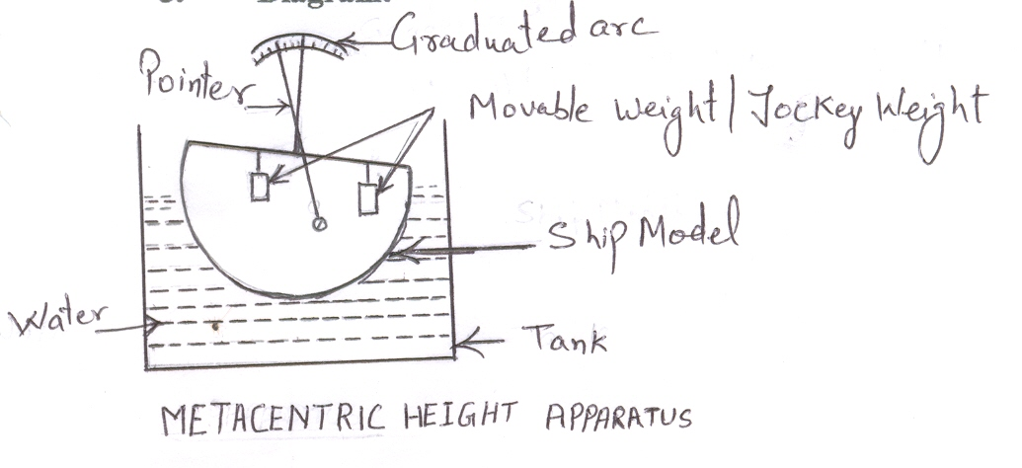
4. Theory:
A body floating in a fluid is subjected to the following system of forces:
a) The downward force of gravity acting on each particle that goes to make up the
weight of body W_{c}acting through the center of gravity G.
b) The upward buoyant force of the fluid acting on the various elements of submerged surface of the floating object F_{B} acting through the center of buoyancy.
For a body to be in equilibrium on the liquid surface, the two forces must be Wc& F_{B} must lie in the same vertical line i.e. these two forces must be collinear and opposite.When the pontoon has been tilted through an angle of Ө, the center of gravity of body G, is usually remained unchanged in its position, but B i.e. center of buoyancy will generally unchanged in its position, thus Wc and F_{B} forms a couple. The line of action of F_{B} in the new position at axis of the body at M, which is called the metacentre and the distance GM, is called metacentric height. The metacentric height is a measure of the static stability of the floating bodies.

The metacentric height can be obtained by equating righting couple and applied moment
= Wm x d
(Wc + Wm) tan θ
Here Wc is weight of pontoon, Wm is weight of unbalanced mass causing moment on the body, d is the distance of the unbalanced mass from the centre of crossbar.

5. Procedure:
i) Note down the relevant dimensions as area of collecting tank, mass density of
water etc.
ii) Note down the water level in the tank when pontoon is not in the tank.
iii) Pontoon is allowed to float in the tank. Note down the reading of water level in the tank. The help of Archimidie 's principle can obtain Mass of pontoon.
iv) Position of unbalanced mass, weight of unbalanced mass and the angle of heel can be noted down calculate the Metacentric height of the pontoon.
v) The procedure is repeated for other position and value of unbalanced mass. Also the procedure is repeated while changing the number of strips in the pontoon.

6. Observations and Calculations:
A) Loaded Condition:
Area of tank =
Rise in water level =
Weight of ship =

Sr. No | Unbalanced mass  Wm | Distance of  Unbalanced  mass | Angle of heel  Ө | Metacentric height  Wm X d  (Wc + Wm) tan Ө
1
2
3

B. Unloaded condition:

Area of tank = 50 X 49 Cm²
Rise in water level =
Weight of ship =9810X.50X.49 X Rise in water level
Sr. No | Unbalanced  mass  Wm  (N) | Distance of  Unbalanced  Mass  (m) | Angle of heel  = l/r  Ө | Metacentric height  Wm x d  (Wc + Wm) tan Ө
1
2
3

7. Result:
i) In case of loaded,
Average Metacentric height = ---
ii) In case of unloaded,
Average Metacentric height = -----

8. Precautions:
i) Apparatus should be in leveled condition.
ii) Reading must be taken in steady condition of water. iii) Measure the angle of tilt accurately

- Question for viva:

i) Can you compare the experimental result with those obtained analytically? If yes, list the formula used.
ii) How would the stability of the pontoon be affected if it were floated on a liquid with a density greater than that of water?
iii) Why care is taken to ensure that the metacentre is above the centre of gravity and center of buoyancy when the pontoon is in a tilted position?

EXPERIMENTS NO.2
To Study the Flow through Variable Area Duct And Verify Bernoulli's Energy Equation
Objective:
To aware the students about energy principle and its experimental verification.

2. Apparatus:
It consists of conduit of varying cross- sectional area as shown in fig3b given below. Transparent acrylic metallic sheets are joined together to form first converging then diverging rectangular conduit of 50X25 on upstream side, 15 X25 in the middle and 50 X 25 downstream side . The length of the conduit pipe is 0.5m.Graduated piezometeric tubes are fitted on the conduit pipe to measure the Piezometric head at each gauge point.
This conduct is connected to an inlet tank. A Piezmetric tube is also connected to the collecting tank for recording the water level in tank. An outlet valve is fitted at
thedown stream end of the pipe.

3. Diagram:

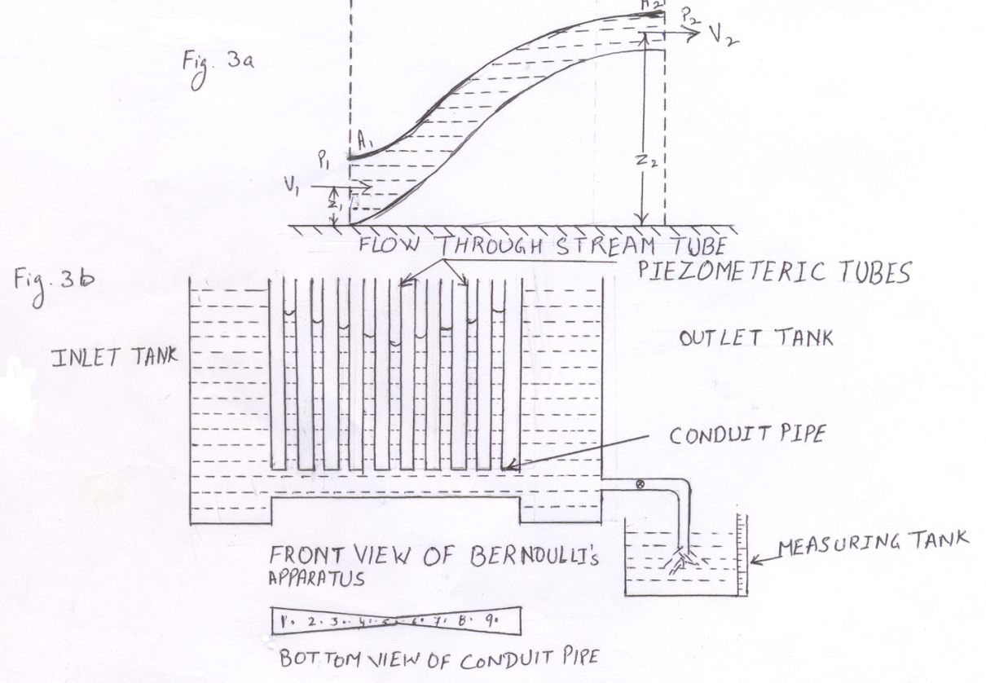
4. Theory:
Daniel Bernoulli enunciated in 1738 that in any s1ream flowing steadily without friction the total energy contained in a given mass is same at every point in its path of flow. This statement is called Bernoulli's theorem.
With reference to section 1-1 and 2-2 along the length of steady flow in the stream tube shown in the figure 3a the total energy at section 1-1 is equal to the total energy at section 2-2 as stated in Bernoulli's theorem.
With usual notations, the expression for total energy contained in a unit weight of fluid at section 1-1 and 2-2 is given by
Total energy at section 1-1 = P₁/w + V₁²/2g + Z₁
Total energy at section 2-2 = P₂/w + V₂²/2g + Z₂
P₁/w= Pressure energy at section 1-1
V₁²/2g = Kinetic energy at section 1-1
Z₁ = Potential energy at section 1-1
P₂/w = Pressure energy at section 2-2
V₂²/2g = Kinetic energy at section 2-2
Z₂ = Potential energy at section 2-2
Thus applying Bernoulli's theorem between section 1-1 and 2-2

P₁/w + V₁²/2g + Z₁ = P₂/w + V₂²/2g + Z₂ (i)

In MKS system, the pressure energy, kinetic energy and potential energy
are measured fluid column per unit weight of fluid. Equation (i) is modified for taking into account the loss of friction between section 1-1 and 2-2 and is written as

P₁/w + V₁²/2g + Z₁ = P₂/w + V₂²/2g + Z₂ + ﴾ ∆ H﴿_{1,2}

Where ﴾ ∆ H﴿_{1,2} represents the loss of energy between sections 1-1 and 2-2

Procedure:

i) Note down the area of the conduit at various gauge points.
ii) Ensure that the apparatus is horizontal with the help of spirit level.
iii) Open the supply valve and adjust the flow so that the water level in the inlet tank remains constant
iv) Measure the height of water-level (above an arbitrarily selected suitable plane) in different piezometric tubes.
v) Measure the discharge of the conduit with the help of measuring tank.
vi) Repeat steps (iii) to (v) for two more discharges

6. Observations & Calculations:
- Discharge

Run No. | Initial Vol.  V₁ | Final vol.  V₂ | Volume Collected  V=V₂ ₋ V₁ | Time Taken  t | Discharge  Q =V/t
Units
1
2
3

- Total head

Piezometric tube No. |  | 1 | 2 | 3 | 4 | 5 | 6 | 7 | 8 | 9
Area of cross-section of conduit at each Gauge point, A
Run No.1 | V=Q/A  V²/2g  P/w + V²/2g +Z
Run No.2 | V=Q/A  V²/2g  P/w + V²/2g +Z
Run No.3 | V=Q/A  V²/2g  P/w + V²/2g +Z

7. Result:
As the conduit is horizontal the total energy at any section with reference to the datum line of the conduit is the sum of P/w & V²/2g energy should be constant for each of the piezometric tube.
8. Precautions:
i) Before taking reading, take care that steady flow conditions are established in
the conduit.
ii) Check that air is not entrapped in the piezometric tube.
iii) There should be no leakage between u/s and d/s end of the conduit.

9. Questions for viva:
i) Where is your datum plane?
ii) If piezometeric tubes are replaced by pressure gauges, then how will you
calculate pressure energy and potential energy of plane?
iii) What are units for P/w,V²/2g & Z?
- What are the applications of Bernoulli's equations?

EXPERIMENTS NO.3
To determine the coefficient of discharge for an obstruction flow meter (venture meter/ orifice meter)

1. Objective:
To aware the students about coefficient of discharge measurement with the help of orifice-meter.

2. Apparatus:

2.1 An orifice meter with tapping at upstream and downstream 2.2 A 'u' tube manometer containingmercury .
2.3 A measuring tank to find actual discharge.
2.4 A stopwatch.

3. Diagram:
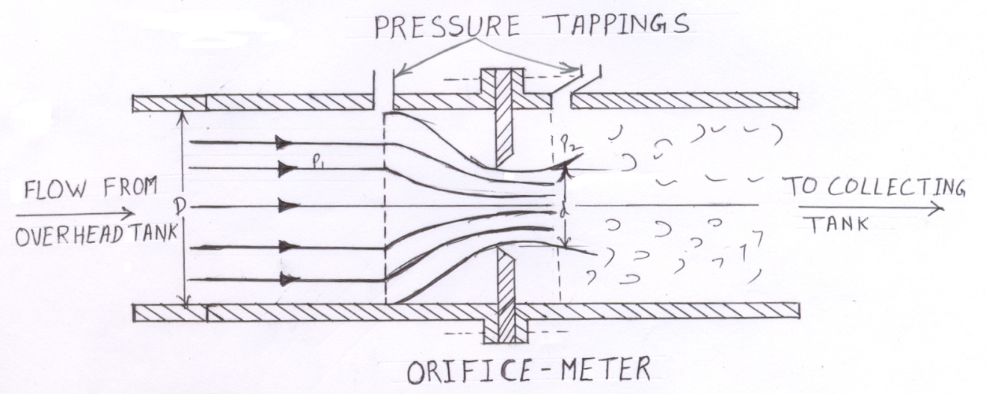
4. Theory:
Orifice-meter, also known as orifice plate meter, is a device used to measure the flow rate in any closed pipeline. It is different from the venturimeter in the sense that it provides sudden change in flow conditions instead of smooth transition provided by the venturimeter. As the liquid passes through the orifice-meter, a lot of eddies are formed and there is loss of energy due to which the measured value of discharge, Q is far less and is given by:
Q = C_{d} [a₁ a₂/√ a₁²-a₂² √ 2g(h₁-h₂) ]
In which C_{d} is the coefficient of discharge of orifice-meter, a₁ is the cross-sectional area of the pipe and a₂ the cross-sectional area of the orifice as shown in fig 3.a. The value of C_{d} varies from 0.6 to 0.62.

5. Procedure:
i) Open the regulating valve so that water starts flowing through the orifice
meter. Wait for some time so that the flow gets stabilized.
ii) Remove air bubbles, if any entrapped in piezometeric tubes.
iii) Note differential manometer readings h₁& h₂.
iv) Measure the discharge by collecting a certain volume of water in a
predetermined time.
v) Repeat steps (iii) & (iv) for different flow rates & take at least three different
sets of observations.
vi) Take another set of manometer readings for calculation of discharge of the
pipeline for constant outflow.

6. Observations and Calculations:
Diameter of the main pipe, D = 25mm
Diameter of the orifice, d = 12.5mm
Area of cross-section of the pipeline, a₁ = 0.4908 X 10⁻³
Area of cross-section of the orifice, a₂ = 0.1227 X 10⁻³
Specific gravity of measuring liquid, S₂ = 13.6
Specific gravity ofliquid flowing in the Pipe, S₁ = 1

Sr. No | Discharge measurement |  |  | Manometer reading |  |  |  | C_{d} =Q (√a₁² -a₂²)/ a₁a₂√2gh
Sr. No | Vo | t | Q=V₀/t | h₁ | h ₂ | h' | h=( S₂/S₁ - l)h' | C_{d} =Q (√a₁² -a₂²)/ a₁a₂√2gh
units
1
2
3

7. Result:
Average Value of C_{d} =

8. Precautions:
i) There should be no air bubbles entrapped while taking reading of liquid level in piezometeric tubes.
ii) Check that the top level of measuring liquid is same in the two limbs of the differential manometer.

9. Question for viva:
- What suggestions do you have for the improving the value of the coefficient of discharge?
ii) What happens to manometer if the pressure in the tapping is too more?
- Which other liquids, we can use instead of mercury in manometer?

EXPERIMENTS NO.4
- Objective:
To aware the students about coefficient of discharge measurement with thehelp of venturimeter.
2. Apparatus:
2.1 A venturimeter with tapping at the mouth and throat give connections to the manometer.
2.2 A 'U' tube manometer containing mercury.
2.3 A measuring tank to find actual discharge
2.4 A stopwatch.

- Diagram:
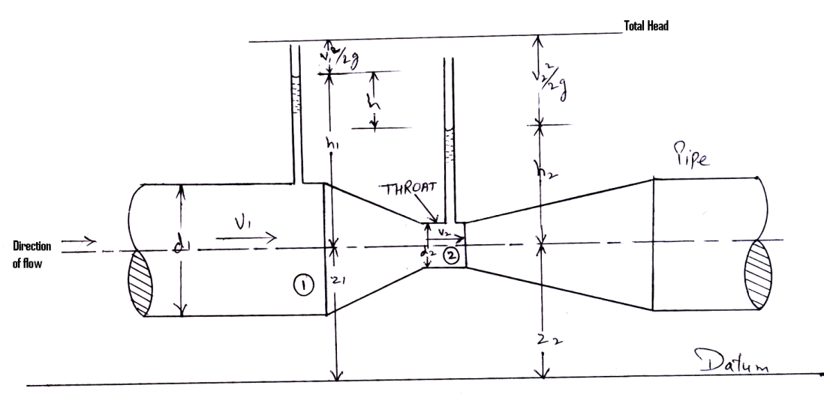
VENTURIMETER
- Theory:
The venturimeter is a device, which has been used over many years for measuring the discharge along the pipe. It consists of a convergent section which reduces in diameter to between one-half and one-fourth of pipe diameter. This is followed bya throat and then a divergent section. The convergent angle is usually 20°. For the divergent part the angle of divergence is usually 5° to 7°.
The fluid flowing in the pipe is led through a contraction section to a throat, which has a smaller cross-sectional area than the pipe. So that the velocity of fluid through the throat is higher in the pipe. This increase of velocity is accompanied bya fall in pressure, the magnitude of which depends on the rate of flow, so that by measuring the pressure drop, the discharge may be calculated.
Beyond the throat the fluid is decelerated in a pipe of slowly diverging section. The pressure increasing as the velocity falls.
With usual notations, the expression for discharge Q, through a venturimeter is given by
Q = a_{l}a₂ √2g(h₁-h₂)
√ a_{l}² -a₂² (i)
Where
a_{l} = area of cross-section of an upstream section
a₂ = area of cross-section at throat
h₁ = piezometric head at the upstream section
h₂ = piezometric head at the throat as shown in fig
g = acceleration due to gravity
In practice there is some loss of energy between section 1 & 2 & the velocity is not absolutely constant across either of these sections. As a result, measured value of Q usually falls a little sort of those calculated from Eq. (i) &It is customary to allow for this discrepancy by writing:
Q = K a_{l}a₂ √2g(h₁-h₂)
√ a_{l}² -a₂²
= [K a_{l}a₂/√ a_{l} ² -a₂²] √ 2gh, where h=h_{l}-h₂ (ii)
In which K is known as the venturimeter coefficient & its value varies slightly
from one venturimeter to another, and even for a given venturimeter it may vary with the discharge, but usually lies within the range of 0.92 to 0.99. In case the piezometric tapping are connected to a differential manometer, then:
h = (S₂/S₁- 1) h'
h' = differential manometer reading
S₂ = sp. gr. of measuring liquid in differential manometer
S₁= sp. gr. of liquid flowing in pipeline.

5. Procedure:
i) Open the regulating valve so that water starts flowing through theventurimeter.
ii) Wait for some time so that the flow gets stabilized.
- Remove air bubbles, if any, entrapped in piezometeric tubes.
iv) Note differential manometer readings hl&h2 .
- Measure the discharge of the apparatus by collecting a certain volume of water in a predetermined time.
- Repeat steps (iii) & (iv) for different flow rates and take at least six different sets of observations.
vii) Take another set of manometer readings for calculation of discharge of the
pipeline for constant outflow.

- Observations and Calculations:

Sr. No | Discharge  measurement |  | Manometer reading |  |  |  | K=Q a_{l}a₂/√ a_{l} ² -a₂²] √ 2gh
Sr. No | Q=V₀/t | t | h₁ | h₂ | h' | h=(S₂/S₁ -l)h' | K=Q a_{l}a₂/√ a_{l} ² -a₂²] √ 2gh
Unit
1
2
3

7. Results:
Average Value of k =
8. Precautions:
i) There should be no air bubble entrapped while taking reading of liquid
level in piezometeric tubes.
ii) Check that the top level of measuring liquid is same in the two limbs of
the differential manometer.
9. Question for discussion:
i) What suggestions do you have for the improving the value of thecoefficient of discharge?
ii) What happens to manometer if the pressure in the tapping is too more?
iii) What are other liquids (more sp. gr.) can be use?

EXPERIMENTS NO.5
Objective:
To aware the students about Vee notch or rectangular notch and their use in measuring coefficient of discharge.

2. Apparatus:
2.1 A weir tank with baffle plates to reduce the velocity of approach
2.2 A Vee-notch or
2.3 A rectangular notch
2.4 A collecting tank

3. Diagram:
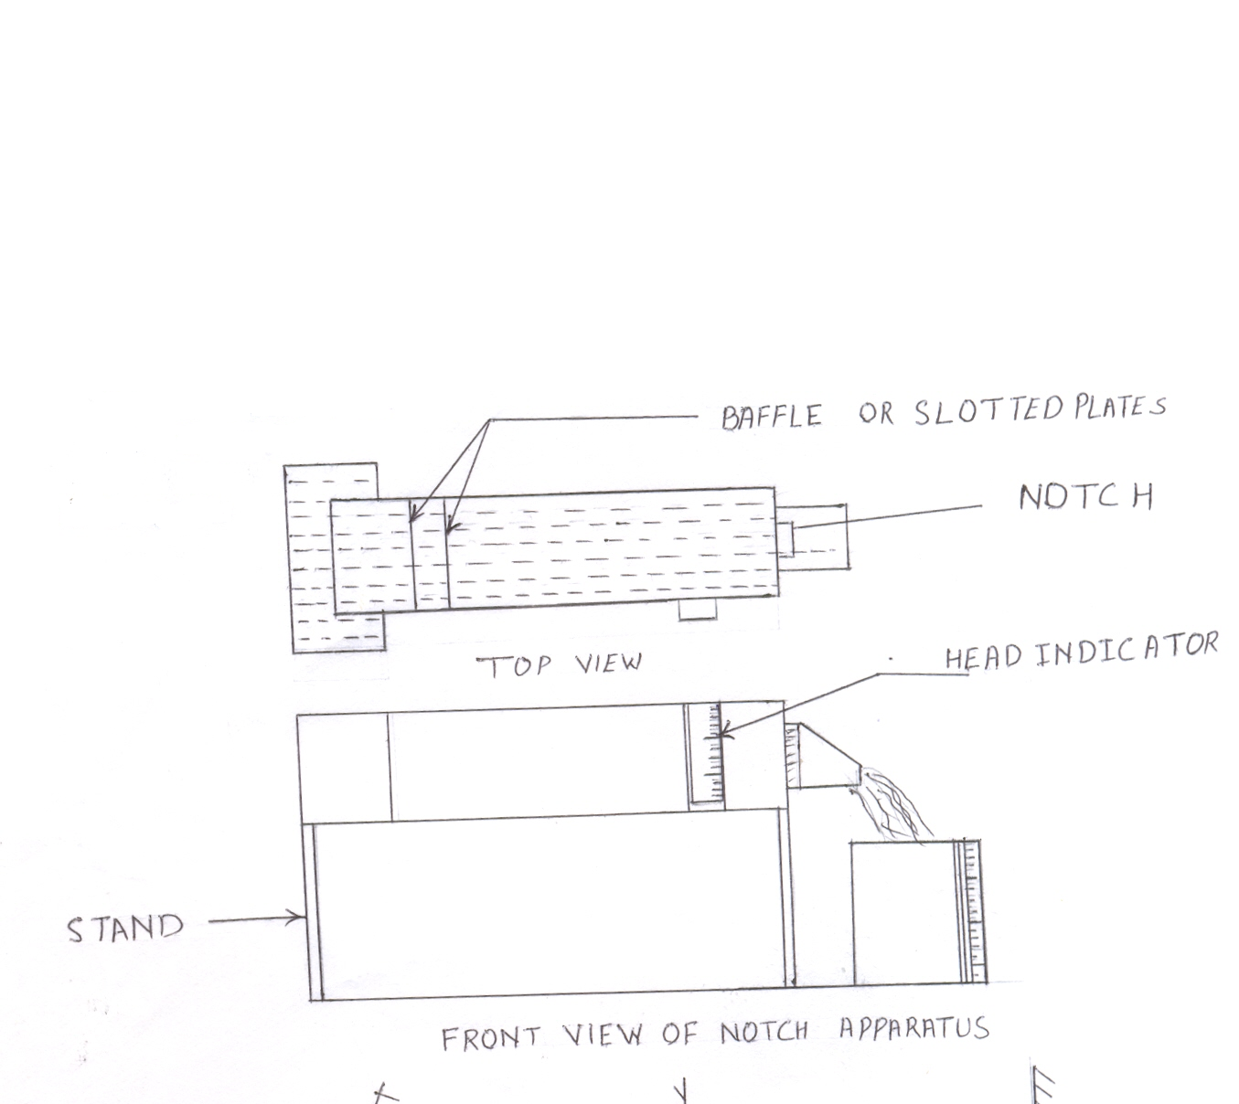
4. Theory:
Notches are commonly used to regulate flow in rivers and other open channels. The relationship between the water- level upstream of the notch and the discharge over it is, generally, known so that the discharge at any time may be found by observing the upstream water level. Notches usually have sharp edges so that the water springs clear of the plate as it passes through the notch.
With the usual notations, the equation for discharge past a sharp-edged notch can be derived in the following form:
For the rectangular notch:

Q=2/3√2g bh^{3/2} (i)

For the triangular notch:

Q=8/15 √2g tan Ө/2h^{5/2} (ii)
Where h, b, Ө are as shown in fig.3a & 3b
The preceding equations are based upon the assumptions listed as follows: a) The height of the water level at the plane of the notch opening is h.
b) The velocity of flow is normal to the plane of the notch opening at all
points.
c) The velocity in the approach channel is negligible.
d) There is no contraction of the stream as it passes through the notch.
In practice, however, none of these assumptions are satisfied. It is, therefore, customary to rewrite the equations in the form:
For the rectangular notch:

Q=2/3√2g bh^{3/2} (iii)

For the triangular notch:

Q=8/15 √2g tan Ө/2h^{5/2} (iv)

Where C_{d} is coefficient of discharge of the notch. It is a non-dimensional number and the dependable way of its determination is by experimentation. A convenient way of finding C_{d} and the exponent of h in either of these expressions is as follows. Either of Eqs. (iii) & (iv) may be written in the form:

Q=K(h)^{n} (v)

Log Q = log K+ N log h (vi)
If experimental results are plotted on a graph having log h as abscissa and log Q as ordinate, then provided that K and n are constant over the range of the results, they will lie on a straight line having slope n and intercept log K on the axis of log Q as indicated in fig 3c.
5. Procedure:
i) Record the width of the rectangular notch.
- The angle of V-notch.
- Level the apparatus by using spirit level.
- Take a series of measurements of discharge and head on the notch by regulating the flow. It is recommended that the rust reading be taken at maximum discharge and subsequent readings with roughly equal decrements in head.
- Discontinue readings when the level falls to a point at which the stream ceases to spring clear of the notch plate. This is likely to occur when the head is reduced to about 1 cm for a rectangular notch and about 2.5 cm for a triangular notch.
- About 3 different discharges for each notch should be noted.

6. Observations and Calculations:
- Rectangular Notch

Width of notch, b =
Sr. No. | Gauge  reading  h | Quantity  of water  collected,  V_{o} | Time  t | Discharge  Q |  | Calculation  of C_{d}
 |  |  |  | Actual = V₀/t | Theoretical=  2/3 √2g bh^{3/2} | Q_{act.}/Q_{th}
Unit | (m) | (m³⁾ | (s) | (m³/s) | (m³/s)
1.
2.
3.

From graph slope n =
Intercept on log Q axis i.e. log k =
The relationship between log Q and log h is thus, Log Q = log k + n log h = Comparing this with Q = C_{d}2/3 √2g bh^{3/2}
Cd = ---

7. Result:
The graph between log Q and log h is a straight line.
8. Precautions:
i) As the correct discharge measurements are very important for this experiment, there should be no leakage at any of the regulating valves.
ii) The width of notch or the angle of the V - notch should be carefully recorded.
iii) The apparatus should be leveled.
9. Questions for Viva:
i) How would you interpret result which, when plotted logarithmically, fall
on a line which is not straight, but slightly curved?
ii) What are changes in result when there is unleveled apparatus?
iii) Why plates are entrapped in the inlet tank?

EXPERIMENTS NO.6
To study the transition from laminar to turbulent flow and to ascertain the lower critical Reynolds number.
1. Objective:
To impart knowledge of laminarand turbulent flow in relation toReynold’s Number.

2. Apparatus:
2.1 A glass tube with a bell mouthed inlet leads from a large tank.
2.2 A dye container is attached to the side- wall of the tank to inject a stream
of dye into the glass tube.
2.3 A measuring tank to find actual discharge
2.4 A stopwatch.
3. Diagram
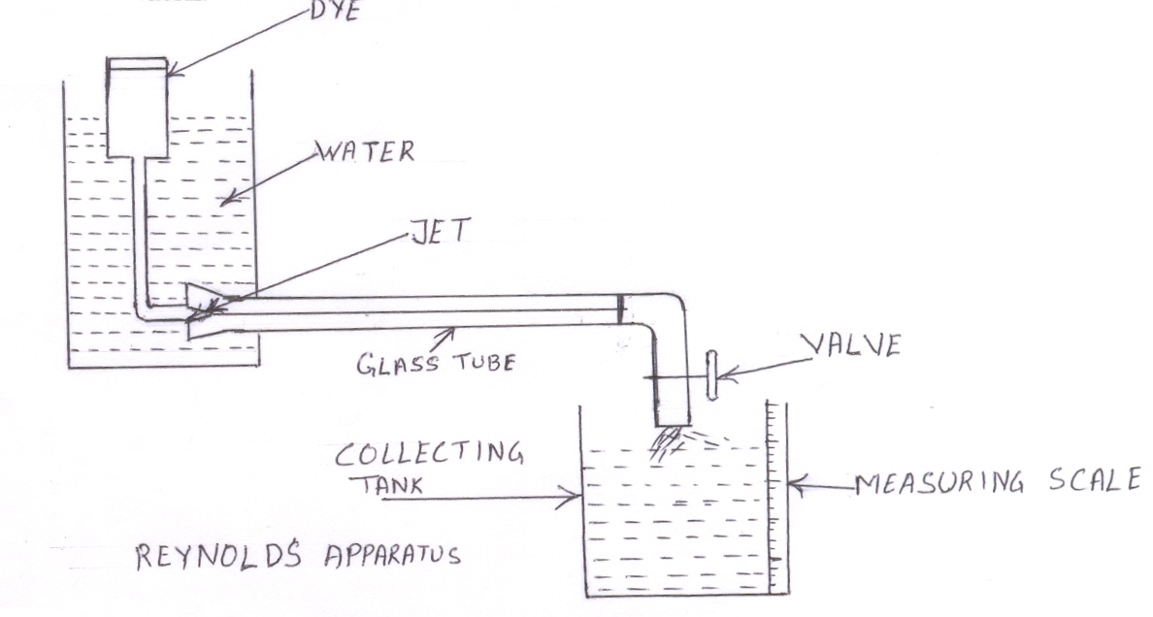
4. Theory:
Osborne Reynolds, in 1883, conducted a number of experiments to determine the laws of resistance in pipes. By introducing a filament of dye into the flow of water along a glass pipe, he showed the existence of two different types of motion. At low velocities the filament appeared as a straight line, which passed down the whole length of the tube, indicating laminar flow. At higher velocities, the filament, after passing little way along the tube, suddenly mixed with the surrounding water, indicating that the motion had now become turbulent.
Experiments with pipes of different diameters & with water at different temperatures led Reynolds to conclude that the parameter, which determine whether the flow shall be laminar or turbulent in any particular case is:
Re = ρVD/μ
In which Re denotes the Reynolds Number of motion
ρ denotes the density of fluid
V denotes the velocity of flow
D denotes the diameter of pipe
μ denotes the coefficient of viscosity of the fluid
The motion is laminaror turbulent according as the value of Re is less than or greater than a certain value. If experiments are made with increasing rate of flow, the value of Re depends on the degree of care which is taken to eliminate disturbances in the supply or along the pipe. On the other hand, if experiments are made with decreasing flow, transition from turbulent to laminar flow takes place at a value of Re which is very much less dependent on initial disturbances. This value of Re is about 2000 for flow through circular tubes, and below this the flow is inherently laminar in nature. The velocity at which the flow in the pipe changes from one type of motion to the other is known as critical velocity and is given by:
V= Re μ / ρ D
Also, the value of critical velocity corresponding to Re = 2000, also known as lower critical Reynolds Number, is called Lower Critical Velocity. The upper critical Reynolds Number (the maximum value of Re at which laminar flow is physically possible) depends largely upon the nature of disturbance present in the flow and may be as high as 40000.
5. Procedure:
i) Open the main supply valve & fill the tank of the apparatus with water, with
outlet of glass tube partly open so that no air is entrapped in the glass tube.
ii) Close the outlet valve of the glass tube and the inlet valve of the tank when
the tank is full.
iii) Leave the apparatus for some time so that water in the tank is at rest. No
disturbance.
iv) Partially open the outlet valve of the glass tube & inlet of the tank so that
velocity of flow is very small and the water level in the tank is fairly
constant.
v) Open inlet of the dye-injector so that the dye stream moves as a straight line
through the tube showing that the flow is laminar.
- Increase the velocity of flow & again measure the discharge.
vii) Take three readings till the dye filament wavers for the first time near the
outlet end of glass tube.
viii) Note down the room temperature at least three times during the experiment
ix) Repeat the experiment with decreasing rate of flow & encircle the reading
for which dye filament wavers for the last time near outlet end of glass tube;
as the flow changes from turbulent to laminar.

6. Observation & Calculations:
Inner diameter of glass tube, D =
Cross-sectional area glass tube, A = (л/4)D²
Mass density of water, ρ =
Average room temperature, Ө =
Dynamic viscosity of water at room temperature, μ =
Volume of water collected, V_{o} =

S.NO | V_{o} | t | Q | V=Q/A | Re= ρ VD/ μ | Ө | Remarks
Units
1
2
3

7. Result:
Average Critical velocity = -------------
=
------

8. Precautions:
i) Don't forget remove any entrapped air in the apparatus before starting
measurement.
ii) There should be no mechanical vibration near the apparatus.
iii) Don't forget to record the temperature of water at frequent intervals.
iv) Increase in velocity of flow should be in stages.

9. Question for viva:
i) Name the dye, which you have used?
ii) On which factor Reynolds apparatus depends.
- What is basic difference between laminar and turbulent flow?
- How we have calculated velocity in a pipe?

EXPERIMENTS NO.7
To determine the hydraulic coefficients for flow through an orifice.
1.Objective:
To visualizes the physical significance of Vena-Contracta& also hydraulic
coefficient of the orifice.

2. Apparatus:
2.1 An orifice tank provided with:
a) A regulate supply.
b) A piezometer tube to measure the head.
c) A horizontal graduated scale with a hook gauge at measurethe coordinates of any point on the jet.
2.2 Micrometer contraction gauge.
2.3 Stopwatch.
2.4 Measuring tank.

3. Diagram:
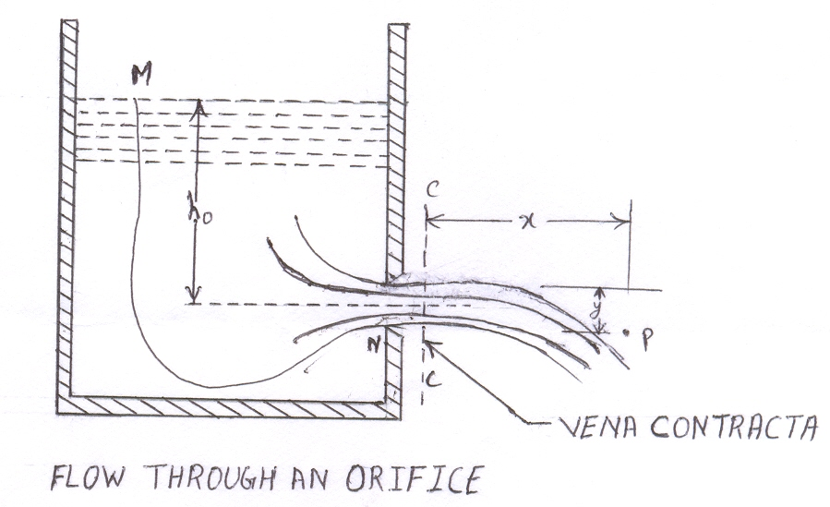
4. Theory:
Fig.3a shows the essential features of flow through an orifice /mouthpiece. The tank is assumed to be sufficiently large for the velocity of flow in it to be negligibly small except close to the orifice. In the vicinity of the orifice the flow accelerates towards the center of the hole so that as the jet emerges, it suffers a reduction of area due to the curvature of the streamlines, as typified by the streamlines MN indicated in the fig3a. The reduction of area due to this local Curvature may be taken to be complete at about half an orifice diameter downstream of the plane of the orifice; the reduction is usually referred as the vena-contracta.

The coefficient of contraction C_{c} is defined as the ratio of the cross-section of the vena-contracta 3c to the cross- section of the orifice, a_{o} i.e.
C_{C} =a_{c}/ a_{o} (i)
Because of the energy loss, which takes place as the water passes down the tank and through the orifice the actual velocity V c in the plane of the vena-contracta, will be less than the theoretical velocity V_{o}.
The ratio of the actual velocity V_{c} and the ideal velocity V_{o} is often referred as the coefficient of velocity C_{v} of the orifice i.e.
C_{v} = V_{c}/ V_{o} (ii)
The theoretical velocity in the plane of vena- contractaV_{o} can be calculated from the equation.
V_{o}/2g = h_{o} i.e.

V_{o} = √2g h_{o} (iii)
The actual velocity in the plane of vena- contracta is given by the equation.

V_{c} = √ (gx²/2y) (iv)
Where x, & y measured positive downward represents the horizontal & vertical coordinates of point P on the trajectory of the jet (origin being taken at the lowest point of the jet at vena- contracta).
Substituting he values of V_{o}&V_{c} in the equation (ii) we get

C_{v}= √(x²/4y h_{o}) (v)
Finally, the coefficient of discharge C_{d} is defined as the ratio of the actual discharge to that which would take place if the jet is discharged at the ideal velocity without reduction of area. The actual discharge Q is given by
Q=V_{c}a_{c} (vi)
& Can be measured with the help of measuring tank and if the
Thus the coefficient of discharge C_{d} is given

Cd =Q/Q_{o}= (V_{c}a_{c})/(V_{o}a_{o})= Q/(a_{o}√2g h_{o}) (vii)

= (a_{c}/ a_{o}) (V_{c}/V_{o}) = C_{c}C_{v} (viii)
5. Procedure:
i) Fix the orifice! Mouth piece of desired shape & size is connected to theopening in the sidewall of the intake tank, near its bottom.
ii) Allow the water to enter the intake tank through the regulating valve &wait till the water level in the tank becomes steady.
iii) Measure the head h using a piezometric tube fixed to the inlet tank.
iv) Measure the discharge corresponding to each value of h.
v) Measure x & y co-ordinates of the lower surface of the jet trajectory atfour different points of the jet at vena- contracta.
vi) Plot graph for Q vs √h

6. Observation & Calculations:
Area of cross- section of orifice, a_{o} =
Reading on the piezometric scale at the
Level of the center of the orifice, h₁=

Determination of C_{d}

S. No | Quantity of  water collected  V | Time  taken  t | Q | C_{d}=Q/(√2gh_{o}) a_{o} | h_{o}
1
2
3

Average value of Cd = --

Determination of C_{v}

S.No | x₀ | y₀ | x' | y' | x= x'- y' | y=y'-y₀ | C_{v}= x/2√yh₀ | Remarks
1
2
3

Average value of C_{v}= --
Then C_{c} = C_{d}/ C_{v} = ---
7. Result:
The variations of √h_{o} with Q should be linear provided C_{d} remains constant over the range of the experiment.
8. Precautions:
i) When taking reading with the piezometric tube check that air is not trapped in this tube.
ii) Take care that water level in the inlet tank is fairly constant when taking a reading.

9. Questions for viva:
i) Supposing that it is not possible to measure the diameter of the jet at the vena
contracta, but that the diameter some distance away from it would the results is
affected?
ii) If, when you plot the graph of h against Q, you obtain a line, which does not
appear to pass through the origin, what possible reasons are there for this? How
will the value of C_{d} obtained from the graph be affected?
iii) In the vicinity of the orifice the flow accelerates towards the center of the hole
why?
iv) Is there any provision to control the flow of intake when rpm of motor vary with electricity fluctuation?

EXPERIMENTS NO.8
To determine the friction coefficient for pipe of different diameters.

1. Objective:
To aware the students about variation of friction coefficient by changing the
dia& length of the pipe.

2. Apparatus:
2.1 Darcy's apparatus consists of three pipes having the diameter 25 mm, 19 nun
and 15mm. The pipes may be 100cm long.
2.2 One common inlet valve is provided in the main supply line for the whole
apparatus.
2.3 Five-pressure tapping is provided at a distance of25cm from the previous one
on each the pipe.
2.4 Five Piezometric tubes.
2.5 A measuring tank.
2.6 A stopwatch
3. Diagram:

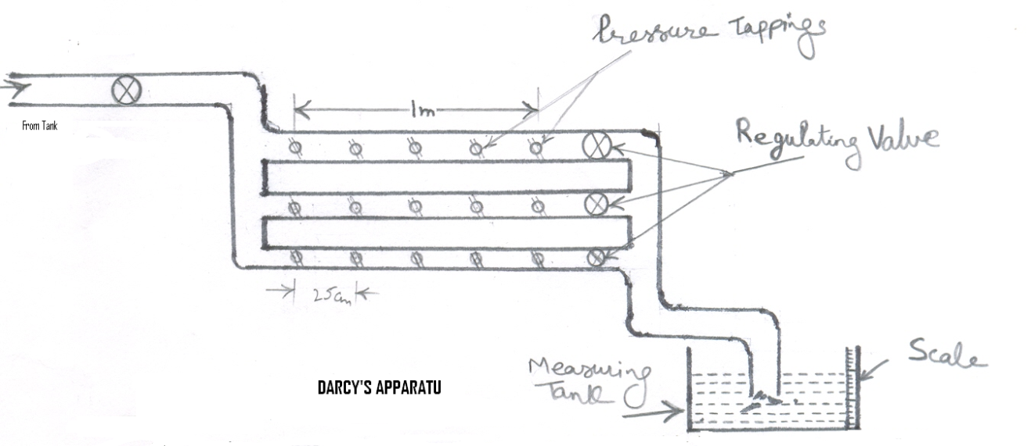
4 Theory:
While the nature of flow depends upon the Reynolds Number, the frictional resistance offered to the flow of fluids depends essentially on the roughness of the surface of the conduit carrying the flow. In laminar flow this frictional resistance is mostly due to viscous resistance of fluid to flow. In turbulent flow it is due to resistance offered by viscosity of fluid and surface roughness of the conduct This frictional resistance causes loss of head ~ which is given by Darcy and
Weisbach equation:
h_{f} = 4fLV²/2gD
Where f is called Darcy's friction factor and given by f = 64/Re for laminar flow and depends upon relative roughness of pipe in case of turbulent flow.

5. Procedure:
i) Connect the Piezometric rubber tubes to gauge points of one of the
pipelines.
ii) Open the inlet valve, keeping the outlet valve closed.
iii) Check if there is any air bubbles in the Piezometric tube. Remove air bubbles
if any.
iv) Open partially the outlet valve, keeping the common inlet valve fully open.
v) Allow the flow to get established and then take Piezometric reading.
vi) Measure the discharge.
- Repeat steps (iv) to (vii) for other pipes.

- Observations and Calculations:

Diameter of pipes
D₁= 25mm
D₂= 19mm
D₃ = 15mm
f= 2gDh_{f}A²/4LQ²

Pipe | Run  No | Discharge measurement |  |  | Piezometric reading |  |  | f= 2gDh_{f}A²/4LQ²
Pipe | Run  No | Volume  Vo | Time  t | Discharge  Q=V/t | h₁ | h₂ | h_{f}=h₁- h₂ | f= 2gDh_{f}A²/4LQ²
Units
Length=  Dia.= | 1
Length=  Dia.= | 2
Length=  Dia.= | 3
Length=  Dia.= | 1
Length=  Dia.= | 2
Length=  Dia.= | 3
Length=  Dia.= | 1
Length=  Dia.= | 2
Length=  Dia.= | 3

7. Result:
i) As the diameter of pipe is increased the value of Darcy's friction factor
Increases.
ii) As the length of pipe increases the value of Darcy's friction factor decreases.
8. Precaution:
i) Take care that there is no air bubbles in the apparatus when taking piezometric
readings.
- There should be no leakage.
9. Question for viva:
i) What happens to Darcy's friction factor by varying the length of pipe?
ii) What is drawback of air bubbles in the tubing?
iii) Wh
EXPERIMENTS NO.9
To determine the head loss in a pipe line due to sudden expansion/ sudden contraction/ bend.
1. Objective:
To aware students about minor losses of the pipes.

2. Apparatus:
2.1 The apparatus consists of a bend, an elbow, a gate valve, a globe valve, a sudden contraction, and a sudden enlargement.
2.2 A "u" tube manometer.
2.3 A stopwatch
2.4 A measuring tank.

3. Diagram:
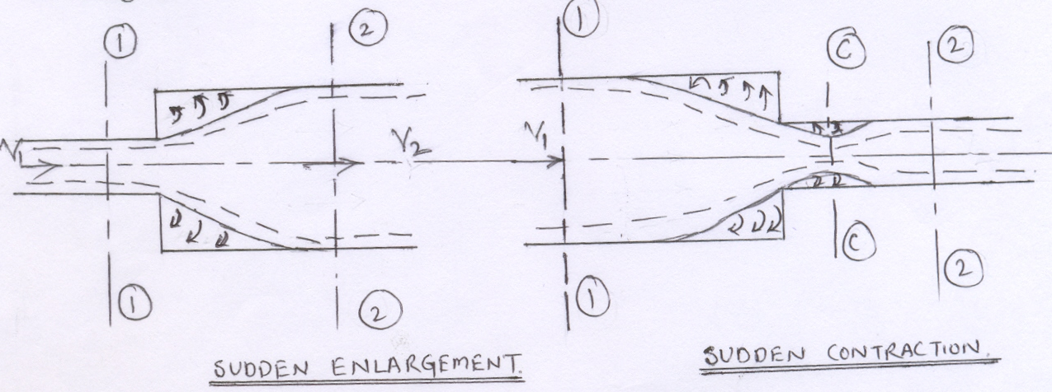

4. Theory:
The frictional resistance causes loss of head h_{f}, which is given by Darcy &
Weisbach Equation.
h_{f}= 4fLv²/2gD
Where f is called Darcy's equation & is given by f = 64/Re for laminar flow & depends upon relative roughness of pipe in case of turbulent flow. But the head losses due to change of section, bend elbows; valves & fittings of all types are classified as minor losses in pipe lines.
Minor losses usually result from rather abrupt changes (in magnitude & direction)
of velocity. In general, increase of velocity (acceleration) is associated with small head loss but decrease of velocity (deceleration) causes large head loss because of the production of large-scale turbulence.
Early experiments with water (at high Reynolds Number) indicated that minor losses very approximately with the square of velocity & lead to the proposal of the basic equation.
h_{L}=kv²/2g

In which k, the loss coefficient is practically constant Loss of head for
A bend = k v²/2g
An elbow = k v²/2g
Gate valve = k v²/2g
Globe valve = k v²/2g
Sudden contraction = 1/2v²/ 2g
Sudden enlargement = (v₁-v₂)²/ 2g

5. Procedure:
i) Open the inlet valve, keeping the outlet valve closed.
ii) Connect the manometer rubber tubing to one of the pipe/pipes fittings & check that
there is no air bubbles entrapped.
iii) Open partially the outlet valve, keeping the common inlet valve fully open.
iv) Allow the flow to get constant & then take manometer reading.
- Measure the discharge.
vi) Take at least three readings.
vii) Repeat steps (i) to (vi) for different fittings.

6. Observation and Calculation:
Diameter of main pipe, D =
Diameter of enlarge pipe, D₁ =
Area of cross- section of main pipe,a =
Area of cross- section of enlarged pipe, a_{l} =
Length of main pipe between pressure tapping, L =
- ----
---
Pipe/s fittings | Run  No. | Discharge measurement |  |  | Velocity of flow in |  | k | h_{f}/ h_{L}
Pipe/s fittings | Run  No. | Volume  of water  collected  Vo | Time  t | Discharge  Q | V = Q/a | Enlarged  Pipe  V_{l} =Q/ a_{l} | k | Calculated | Measured
Bend
Elbow
Gate valve
Globe valve
Sudden
Enlargement
Sudden
Contraction

7. Result:
The friction resistance varies:
- with the degree of roughness of surface with which fluid comes in contact
ii) with the extent of area of surface coming in contact with fluid
8. Precautions:
i) Take care that there is no air bubble entrapped in the apparatus when taking
manometer reading.
ii) There should be no leakage from any of the pipe fittings.

9. Question for viva:
i) Name the manometer, which we have used in this equipment?
ii) In which tapping we have more losses?
iii) Why these losses are called minor losses?
Experiments No.10
To determine the velocity distribution for pipeline flow with a pitot static probe.

1. Objective:
To aware the students about velocity distributions due to friction & its practical measurement.

2. Apparatus:
2.1 A Pitot tube
2.2 A channel having moving water
2.3 A "U" tube manometer
2.4 Measuring tank
2.5 A Stopwatch

3. Diagram:

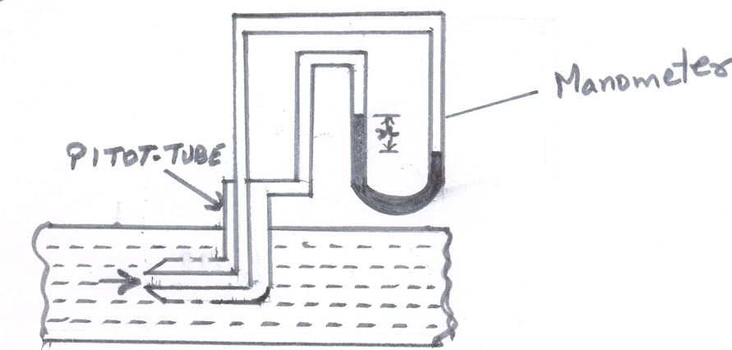
4. Theory:
Velocity measurements in pipes as well as in open channels can be found by measuring the pressure corresponding to the kinetic energy of flow. The simplest method is to measure the pressure in an open- ended tube bent in such a way that the end is aligned opposite to the velocity vector measured; such tubes are called Pitot tubes. Invented by a French Scientist, Henry Pitot (1695 - 1771) in 1732, this tube was first used to measure the flow of river Seine in Paris. The kinetic energy at the center of this tube converts into pressure energy as the flow of fluid is halted at that point as shown in fig 1).
The inner end, which is bent through 90 º, is directed as shown in fig. 1 ). The liquid rises up in the tube due to the conversion of kinetic energy into pressure energy. The velocity is determined by measuring the rise of liquid in the tube.
Consider two points (1) & (2) at the same level in such a way that point (2) is just at the inlet of the Pitot tube & point (1) is far away from the tube.
Let
P₁ = Intensity of pressure at point (1)
V₁ = Velocity of flow at (1)
P₂ = Intensity of pressure at point (2)
V₂ = Velocity of flow at (2) which is zero.
h = Rise of liquid in the tube above the free surface.
Applying Bernoulli's equation at points (1) & (2)
We get
P₁/ ρ g + V₁²/2g + Z₁ = P₂/ ρ g + V₂²/2g + Z ₂
But Z₁ = Z₂aspts (1) & (2) are on the same line & V₂ = 0
P₁/ ρ g = Pressure head at (1) = H
P₂/ ρ g = Pressure head at (2) = h
substituting these values, we get
H + V₁²/2g = h + H
h = V₁²/2g or
V₁ = √2gh

5. Procedure:
i) Connect the Pitot - tube to the manometer through rubber tubing.
ii) Start the motor & regulate the inlet valve.
iii) Open the outlet valve and allow the flow to take place for some time.
iv) Note down the manometer's reading.
v) Repeat by taking different discharges.

6. Observation and Calculation:

S. No | Manometer  Reading |  | head  h' | h⁰ | V = √2gh
S. No | h₁ | h₂ | h₁- h₂ | h=( s₂/s₁-1) h' | V = √2gh
Units
1
2
3

7. Result:
Average Velocity = -----
8. Precaution:
Check that no air bubbles is entrapped in Pitot - tube or in the manometer while taking observations.
9. Questions for viva:
i) On which basic equation our Pitot - tube based?
ii) Is there coefficient of Pi tot?
iii) Why Pitot - tube is called Pitot Static tube?

BTCE-307 STRENGTH OF MATERIAL LAB

LIST OF EXPERIMENTS:

1. Draw Stress Strain curve for Ductile and Brittle material in tension.
2. Draw Stress Strain curve for Ductile and Brittle material in compression.
3. Draw shear stress, shear strain curve for ductile and brittle material in torsion strength testing
4. Draw load deflection curve for spring in loading and unloading conditions.
5. To determine the hardness of the given material by Rockwell and Brinell hardness testing machine.
6. To determine the fatigue strength of the material.
7. To determine the impact strength by Izod and Charpy test.
8. To determine the load carrying capacity of the leaf spring.
9. To test a mild steel and cast iron specimen in double shear.

BTME-308 Strength of Materials Lab
EXPERIMENT NO-1

AIM:To perform tensile test in ductile &brittle material & to draw stress-strain curve & to determine various mechanical properties.

REQUIREMENTS:

- Universal Testing Machine(UTM)
- Test specimen
- Micrometer
- Steel scale

THEORY:
A tensile force is one which alongates a member. When a metal piece is loaded by tensile force, metal piece (Test sample) gets a tensile strain. Tensile test consists in straining a test piece by tensile stress, generally to fracture, with a view of determining one or more of the continuously properties. This test is done on UTM.

UTM
A UTM consists of:
- Loading Unit
- Control Unit

- Loading Unit: This unit consists of two cross heads and one lower table. Upper & Lower table are rigidly connected to columns operated by hydraulically operated piston . Lower crosshead can be moved up and down by rotating to screwed columns by chain and sprocket drive of the motor mounted in the base of this unit. Specimen is fixed between two cross heads and table according to tensile or compression test. For tensile test the specimen is fixed between lower crosshead and upper crosshead. For the compression test the specimen is inserted rotating the four handles each provided in the upper cross head and lower crosshead.

2. Control Unit: This is to measure continuously the load being applied to the teat piece. This unit incorporates switches and push buttons to operate motors of pump as well as vertical screwed columns. The hydraulic cylinder of the loading unit is connected through pipe and operated by a high pressure pump driven by a electric motor fitted in this control unit. For measuring the magnitude of force on the test piece the cylinder is connected by pressure pipe to the between the lower table and lower cross head. The tensile test piece is fixed in the rack jaws by control unit were a pendulum dynamometer operates the pointer of measuring gauge through rack and pinion arrangement.

PROCEDURE:

- The diameter of the test piece is measured by means of a micrometer at least at three plane and determine the mean value. The gauge length is marked.
- Suitable scale is selected.
- The test specimen in the grips is inserted by adjusting the cross-heads of the machine.
- Fix the extensometer on the test piece and set its scale dials to zero position.
- Graph recording system is activated.
- Machine is started and readings of dials on the extensometer is taken for a particular value of load.
- The rate of loading may be 10 mpc/sec initially and should be reduced to 7.5mpc/sec. when the yield point is reached.
- Load is applied continuously till the specimen breaks and then stop the machine.
- Plot load vs extension diagram.

OBSERVATION:

Gauge length (Lo) =
Original dia. of specimen (d) = 10mm
Dia after fracture (du) =
Total length after fracture (Lu) =

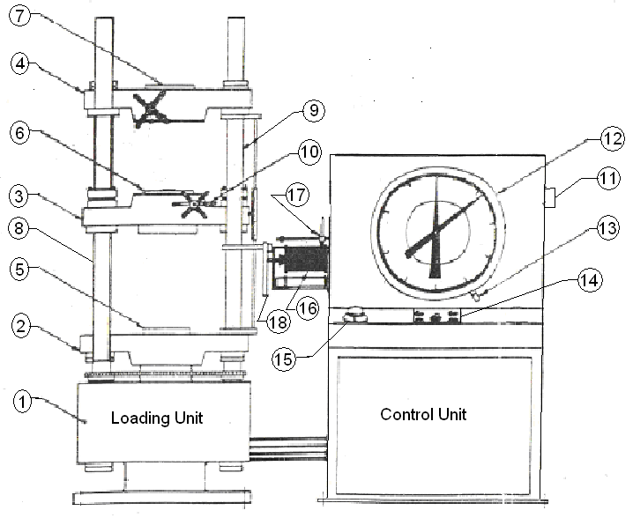

Universal Testing Machine

Main Parts:

- Base  - Lower table  - Lower Cross head  - Upper Cross head  - Compression test Attachment  - Gripper (Lower Cross head)  - Gripper (Upper Cross hwead)  - Piston Column  - Screwed Column  - Gripper Handle | - Main Switch  - Dial Gauge  - Calibrator  - Push button for Piston operation  - Button for screwed column  - Graph paper  - Ink Pen  - Extensiometer

CALCULATIONS:

Stress (Strength) = Load/Area
Percentage elongation = 100(Lu-Lo)/Lo
Percentage reduction in area = 100(Su-So)/So

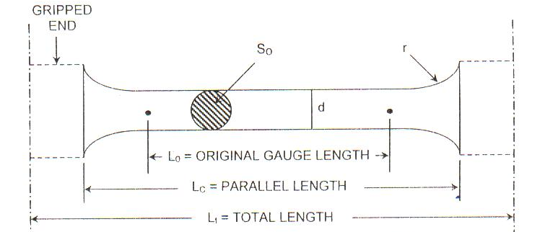

Desired Dimension of a circular test piece

RESULTS:
Proportional limit, Mpa =
Yield strength, Mpa =
Ultimate Strength, Mpa =
Breaking strength, MPa =
Modulus of elasticity(GPa) =
Percentage elongation =
Percentage reduction in area =

Experiment No-2

AIM: To perform Compression test on C.I. & to determine ultiamate compressive strength.

REQUIREMENTS:
- Universal Testing Machine
- Test piece

THEORY:
Compression Test consists in straining a test piece by compression loading. Specimen for compression test on metal are usually circular, and for concrete square, in-section. To prevent failure by bulking, the length should be of about the same order as the minimum width. In the ductile material distortion takes place while in case of brittle materials, usually fail by shearing.

PROCEDURE:
- Measure the diameter of the test piece at three different planes and take the average value.
- Place the specimen between middle and lower cross heads and apply the compressive load.
- Increase the load gradually until the specimen fails.

OBSERVATIONS:
Ultimate load =
Average diameter of test piece (D) =

CALCULATIONS:
Cross-sectional area =
Ultimate compressive strength =

PRECAUTIONS:
- 1. The specimen should be straight and ends of specimen must be at right angle to the axis of specimen.
- The length of specimen has to be kept small to avoid the buckling of the specimen.

RESULT:

Ultimate Compressive Strength =

Experiment No-3

AIM:To find out Rockwell Hardness Number of given test piece.
REQUIREMENTS:
1. Rockwell Hardness Tester
2. Test Piece
3. 1/16” Ball and Diamond Indentor
4. Microscope
THEORY:
Hardness represents the resistance of a material to indentation, and involves the measurement of plastic deformation caused when a loaded ball or diamond is applied to the surface of material.
Rockwell Method: In this a hardened steel ball is pressed into the surface under a specified load which is held on for a fixed period and then released.

PROCEDURE:
1. Place the test specimen and the test table of the testing machine.
2. Apply load slowly and progressively to the specimen at right angle to the surface and maintain full load for 15 seconds.
3. When the dial indicator reached a stable position and the handle has reached the end forward position, the applied load is taken off by pushing the loading handle to the rear position without jerk.The hardness number is now indicated on the dial at the appropriate scale.

OBSERVATIONS:
Material of test piece =
Diameter of ball =
Load 'F' =
Load application time =

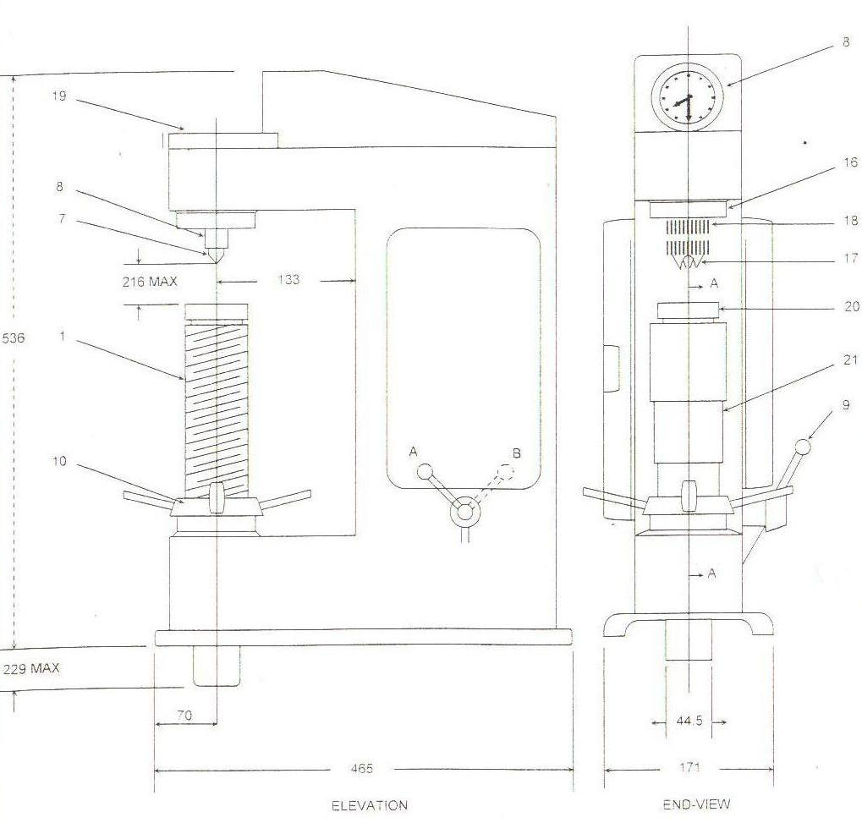

Rockwell and BrinellHardness Testing Machine
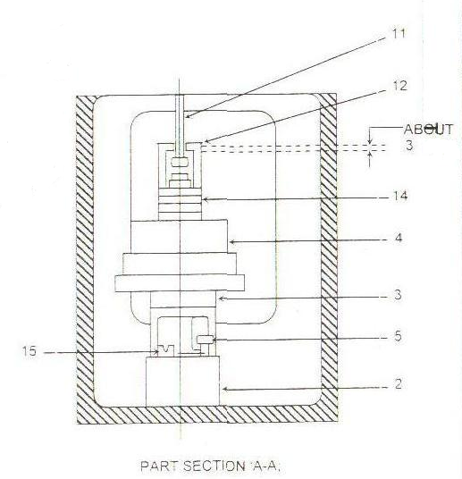

- Main Screw
- Dash Pot
- Plunger
- Loads
- Valve Screw
- Dial Gayge
- Indentor
- Diamond Holder
- lever
- Hand wheel
- Load hanger
- Weight shaft clip
14. Washers
15. Left side screw
16. Diamond holder cap
17. Clamping cone
18. Clamping check nut
19. Top plate
20. Test table
21. Telescope cover

Rockwell hardness scales for measuring hardness of different materials as shown in following table:
Rockwell hardness scale

Scale symbol | Indentor | Major load  Kgs | Dial fig | Typical applications
B | 1/16” ball | 100 | Red | Copper alloys,softsteels,iron,Al
C | Diamond | 150 | Black | Steel,HardCI,paralytic malleable iron,titanium and other materials harder than B 100
A | Diamond | 60 | Black | Cemented carbide,thin steels and shallow case hardening

PRECAUTIONS:
1. The surface of test piece should be smooth and test spot free of oil and dirt should be polished to get a clear impression.
2. The load value of indenter diameter should be selected from table 1 depending upon material of test specimen of its thickness.

RESULT:
Rockwell Hardness =

Experiment No-4

AIM:To study the Impact Testing Machine & perform the Impact Test (Izod&Charpy).

REQUIREMENTS:
1. Impact Testing Machine
2. Specimen

THEORY:
Impact Test: The test is to determine the behavior of materials when subjected to sudden loading.
Charpy Impact Test: It is single blow Impact test, in which the notched specimen is supported at both ends, as a simple beam & broken by a falling pendulum on face opposite to and immediately behind the notch.
Izod Impact Test: It is a single blow Impact test, in which the notched specimen is fixed at one end and broken by a falling pendulum.
Impact Strength: Energy absorbed by specimen during impact test is known as impact strength.

PROCEDURE:
1. Set the needle of scale at zero position.
2. Raise the pendulum (P kg) to an appropriate height 'h1'. 'h1' depends upon energy stored (300 N-m).
3. Locate the specimen on its proper place according to test.
4. Pendulum is dropped freely from height 'h1'. The pendulum will break the test specimen and shoot up to the other side of the machine.
5. The pendulum is stopped with the help of broken operated by a lever.
6. Residual energy indicated on the scale by the pendulum is noted.
7. The impact strength of the test piece is the difference of the initial energy stored in the hammer and the residual energy.

CALCULATION:
Impact Strength (E) = E1-E2 = P(h1-h2) kgm
Where
E1 = Energy stored before Impact
E2 = Energy stored after Impact.
OBSERVATION:
Material of test piece:
Dimension of test piece:
Initial Energy (E1):
Residual Energy (E2):
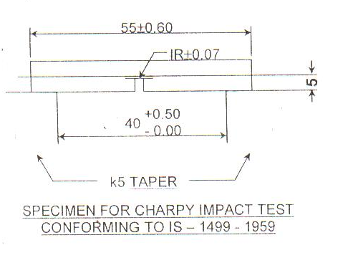

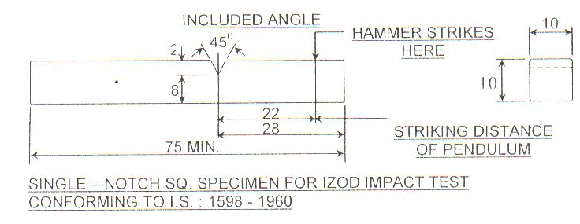

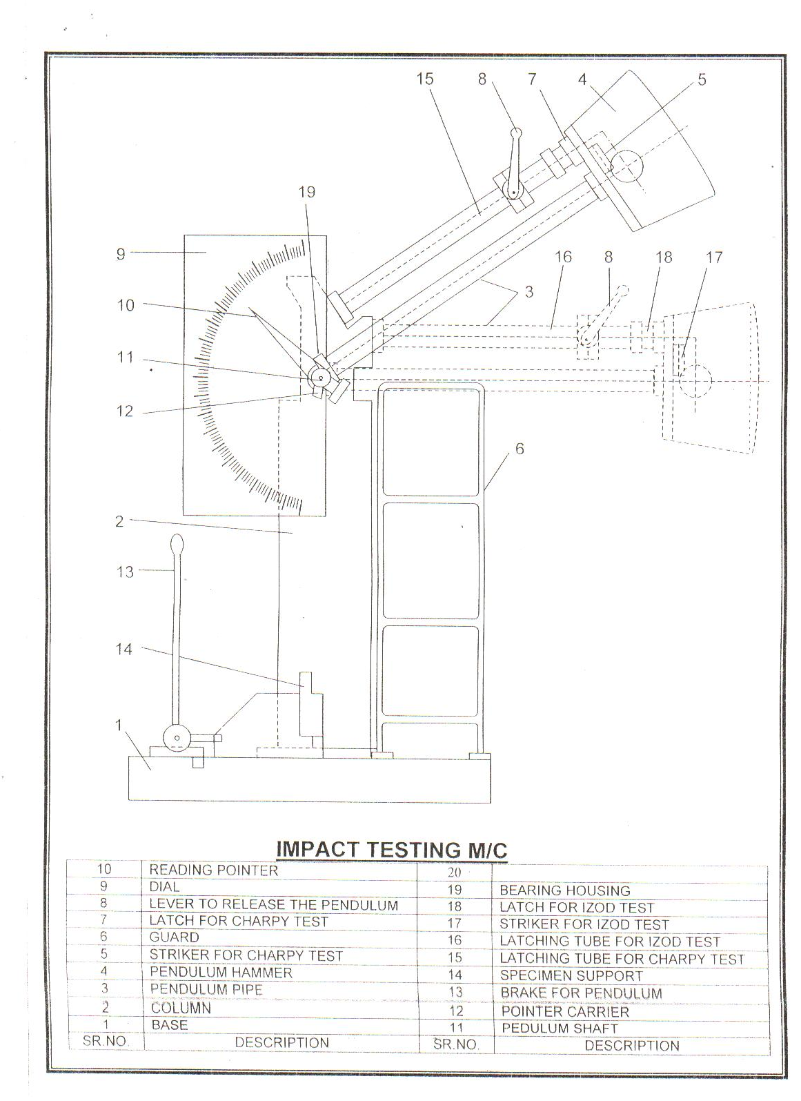

PRECAUTIONS:
1. One should not stand in the swinging line of pendulum.
2. Hammer should be in 'locking' position when the specimen is being placed for testing.
3. Keep the machine in locking position after the practical is over.

RESULT:
Impact Strength of specimen = --------kgm

Experiment No-5

AIM: To study the Torsion Testing Machine & perform torsion test.

REQUIREMENTS:
1. Torsion Testing Machine
2. Specimen
3. Micrometer
4. Steel Scale

THEORY:
A circular cylindrical shaft is said to be subjected to pure torsion when the torsion is caused by a couple, so that the axis of the applied couple coincides with the axis of the shaft. In such a case the state of stress at any point in the cross-section of the shaft is pure shear.
Torsional formula is given by:
T/J = t/r =Gθ/L
Where,
T= Twisting Moment
J= Poller M.O.I. of original cross-section
t= Shear Stress induced in specimen
r= Radius of original cross-section
G= Modulus of Rigidity
θ= Angle of Twist
L= Perallel length of initial specimen
PROCEDURE:
1. Measure the diameter of the test piece of four different planes on its parallel length by using a Micrometer. At each plane measure the diameter at right angle to each other.
2. Measure the parallel length of the test piece.
3. Insert the test piece in the grips of the machine.
4. Select a suitable scale on the digital indicator and adjust the initial torque and angle of twist reading to zero position.
5. Apply the torque on specimen with the driving chuck. To activate the driving chuck,switch on the. Electrical lever control, with this, the test specimen start twisting and with the increased load, the digital display on the digital indicator unit progressed
6. Torque is applied untill specimen breaks and maximum torque that sample has taken is read out from Digital Indicator unit by pressing the PEAK push button.
7. Angle of twist is noted from Angle of twist measuring wheel after the specimen has failed.
8. Initially a line may be marked parallel to the length of the test piece to visually see the helix formation.
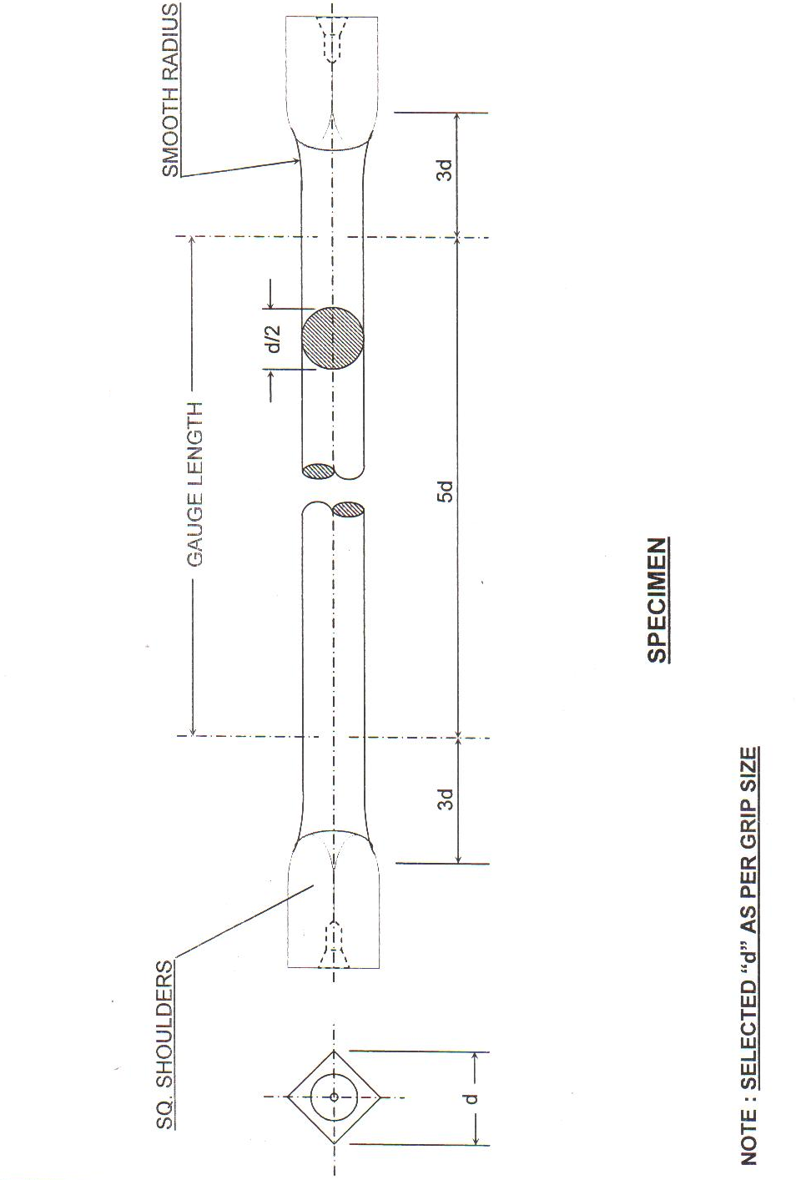
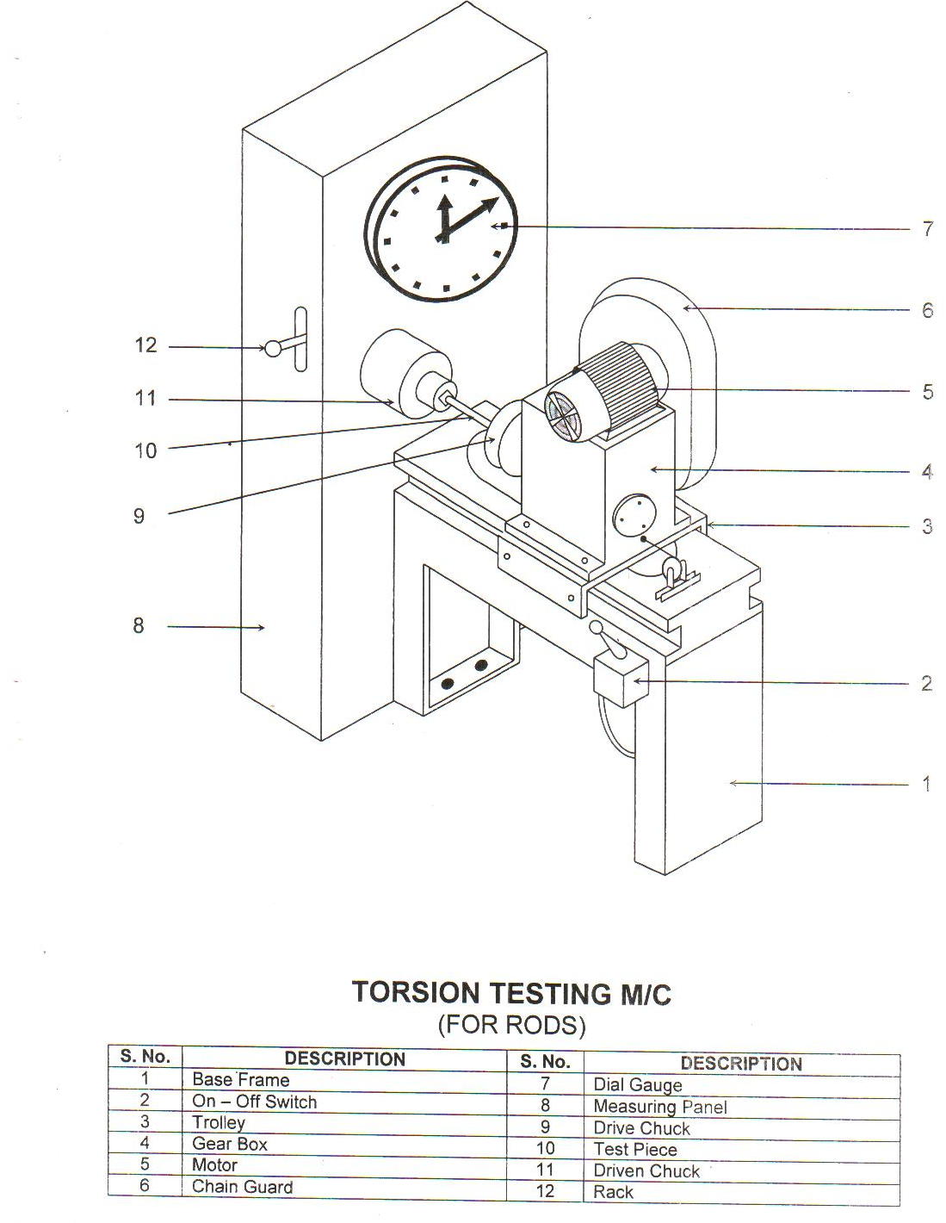

OBSERVATIONS:-

1. Material of test specimen=
2. Least count of micrometer=
3. Parallel length of test specimen=
4. Diameter:
5. Maximum torque (N-m) =
6. Breaking torque (N-m) =
7. Angle of twist Ø =

CALCULATIONS:-
Modulus of rupture ts = Tr/J
Modulus of rigidity G = Tl/Jθ
Where:
T= Maximum twisting moment.
r= Original outer radius of specimen
J= Polar moment of inertia of the original cross-section
θ= Angle of twist
l= Parallel length of specimen.

RESULTS:-

1.Maximum torque=

2.Breaking torque=

3.Total angle of twist to fracture

4.Modulus of rupture=

5.Modulus of rigidity=

Experiment No-6

AIM:To Study of performance of Steel pieces under Fatigue and Creep test.

REQUIREMENTS:
- Test Pieces
- Rotary Bending fatigue Machine

THEORY:
Fatigue is defined as failure of a material under varying loads well beloe the ultimate static load after a finite number of cycles of loading and unloading.The equipment to test the fatigue characterstics basically consist of basically some way of producing alternative loads to the specimen, some counting arrangement for the no of load cycles and some load measuring device. Control devices are to stop the motor on breaking of specimen are provided.

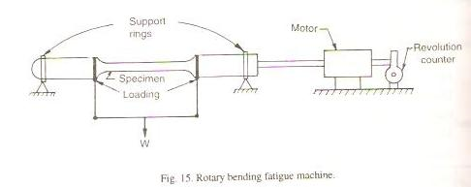

PROCEDURE
- Insert the test piece in the bearing housing of the machine abnd measure its diameter.
- Apply suitable load.
- Set the revolution counter to zero
- Start the motor of machine and record the no of revolution after which the specimen fails
- Increase the load and test other specimen in the same way
- In each test calculate the stress (σ) applied.
- Plot a curve between σ and log N(no of cycles)

OBSEVATIONS

Diameter of test piece d(mm) | Load, W | No of cycles(N) | Stress(N/mm2) σ

Experiment No-7

AIM- To perform bending test of beam(wooden or any other material) and to determine the Youngs Modulus of rupture.

Requirements:
- Deflection Of beam Apparatus
- Weights
- Dial Gauge
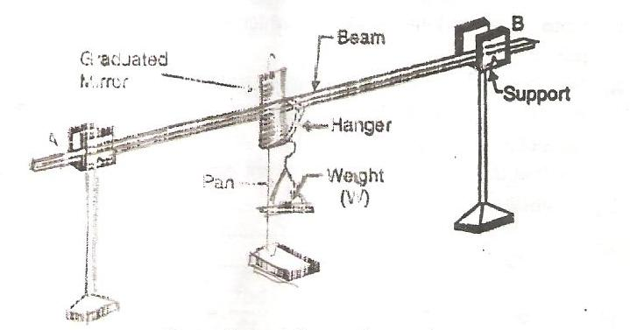

THEORY:
It consists of a beam supported at to knife edged supports. The beam carries a hanger to which Pan and weight can be attached. When Load W is put in thje pan at the centre C the deflection is caused in the beam.

Let,
Y = Deflection at the centre C of the Beam
Y= Wl3/48EI
E= Wl3/48IY

Where,
l = Length of beam between supports
E= Young’s modulus of Elasticity
W= Load acting at centre of beam
I= Moment of Inertia = bd3/12, Where,

b= width of beam
D=depth of beam

PROCEDURE:

- Measure the length, Width and depth of the beam
- Note down the initial reading at which the pointer stands through the mirror.
- Put the load in the pan and again note the reading. Difference of 2 readings gives the deflection of beam under load W.
- Repeat the experiment for different beams.

OBSERVATION:
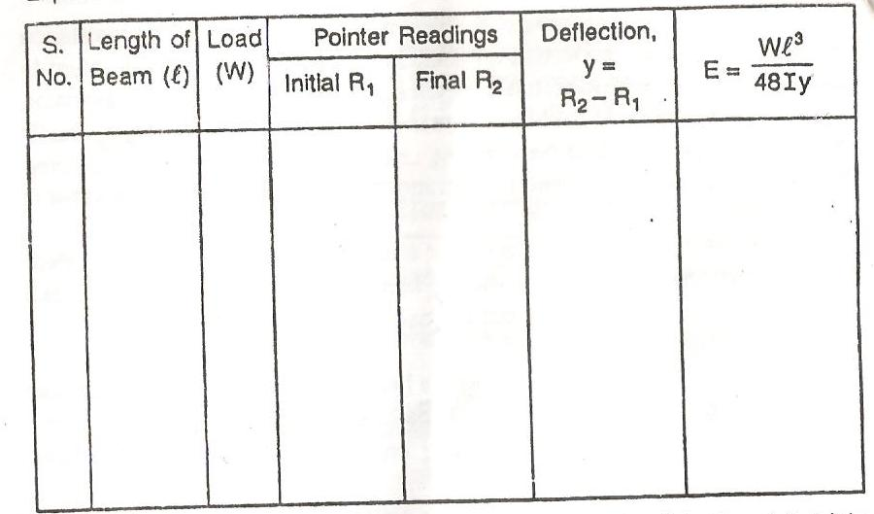

PRECAUTIONS:

- The initial reading of beam must be taken every time and very carefully.
- Cross section of beam should not be heavy.

Experiment No-9

AIM: -To perform torsion test on closed coil helical spring in tension and compression and to determine stiffness of springs.

APPARATUS: - Spring testing machine, helical springs, micrometer, weights etc.

Description of the apparatus: Spring testing machine consists of a rectangular of metal frame with channel sections along both the vertical sides. It is provided with holes in each corner for fixing the apparatus by means of bolts embedded in the vertical support. The nuts are screwed tightly on the bolts.

On the vertical side of the channel, a scale (S) marked in cm and mm is provided to measure the extensions ( or compression) caused the applied load.

Between the side channels, a movable frame with vernier (V) marked units-10, attached with a rod, moves freely when load is applied at the bottom hook (C). There is a hook (B) on the top of this movable frame.

Another frame at the top is fixed with the channel sections of the metal frame. The top frame has a horizontal top head with a screw at top and a hook (A) in the centre, below the top head.

When tensile loads are applied at bottom hook (C), the spring is attached between the hooks A & B.

PROCEDURE: -

- Put both the springs on the hooks provided

- Note down the initial reading before the application of load or adjust the initial reading to read 0-0.

- Apply a load W1 on the springs which causes an extension in the tension spring and compression in the compression spring. Note down the reading on the scale to measure the extension (δ1) in mm. Increase the loads gradually from W2, W3, W4, and so on.... Within the elastic limit and record the extension δ2, δ3, δ4,.....

Plot the graph between load and extension ( deflection).

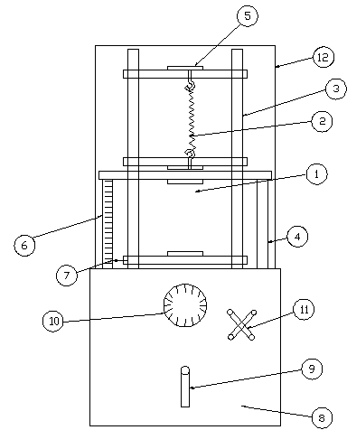
Spring Testing Machine
1 | Compression Spring
2 | Tension Spring
3 | Twin Rods From Piston
4 | Frame
5 | Adjusting Knob
6 | Measuring Scale
7 | Pointer
8 | Panel
9 | Manual Handle for Pump
10 | Force Gauge
11 | Pressure Release valve handle
12 | Protection Frame

Observations and Calculations :-
(For tension as well as compression springs)

Mark the different points on the graph according to observations. Then pass a mean straight line through this plotted points.

Take any two points A and B on the mean straight line. Measure AC which gives the mean value of extension (δ). Measure BC which gives the mean value of load (W).

Axial tensile Load (W) in KN | W1........ | W2........ | W3....... | W4........
Extension Deflection (δ) in mm | δ1.......... | δ2.......... | δ3......... | δ4.........

Stiffness of the spring(δ) =...............KN/mm

PRECAUTIONS: -

- Apply the loads gradually without jerks.
- Record the reading correctly with the help of vernier provided on movable frame.
- See that the movable frame with the pointer moves freely without any friction.
- The graduation of the scale should be clearly visible and readable.

BTCE-305 SURVEYING LAB

LIST OF EXPERIMENTS:

1. Measurement of distance, ranging a line.
2. Measurement of bearing and angles with compass, adjustment of traverse by graphicalmethod.
3. Different methods of leveling, height of instrument, rise & fall methods.
4. Measurement of horizontal and vertical angle by theodolite.
5. Determination of tachometric constants and determination of reduced levels by tachometricobservations.
6. Plane table survey, different methods of plotting, two point & three point problem.
7. Determination of height of an inaccessible object.
8. Setting out a transition curve. Setting out of circular curves in the field using differentmethods.

SURVEYING LAB I

MANUAL

S.No Name of the experiment

- Survey of an area by Chain Survey (Closed Traverse) & Plotting

- Chaining across Obstacles

- Determination of two inaccessible points with Compass

- Survey of a given area by Prismatic Compass (Closed Traverse) and plotting after adjustment

- Radiation, Intersection Methods of Plane Table Surveying

- Two Point and Three Point Problem in Plane Table Survey

- Traversing by Plane Table Surveying

- Fly Leveling (Differential Leveling)

- An exercise of L.S. and L. S. and Plotting

- Two Exercises on Contouring

FAMILARITY WITH INSTRUMENTS USED IN CHAIN SURVEYING

OBJECTIVE: Study of various instruments used in chain surveying and their uses

INSTRUMENTS:

- Chain or tape

- Arrows

- Ranging rods

- Cross staff

- Offset rods

- Pegs

- Plumb bob

DESCRIPTION OF INSTRUMENTS:

1 a) Chain:

The chain is composed of 100 or 150 pieces of galvanized mild steel wire, 4mm in diameter called links .The ends of each link are bent into a loop and connected together by means of three oval rings. The ends of the chain are provided with handles for dragging the chain on the ground, each wire with a swivel joint so that the chain can be turned without twisting. The length of the chain is measured from the outside of one handle to the outside of another handle.

Following are the various types of chain in common use:

- Metric chains

- Gunter` s chain or surveyors chain

- Engineers chain

- Revenue chain

- Steel band or Band chain

Metric chain:

Metric chains are made in lengths 20m and 30m. Tallies are fixed at every five-meter length and brass rings are provided at every meter length except where tallies are attached
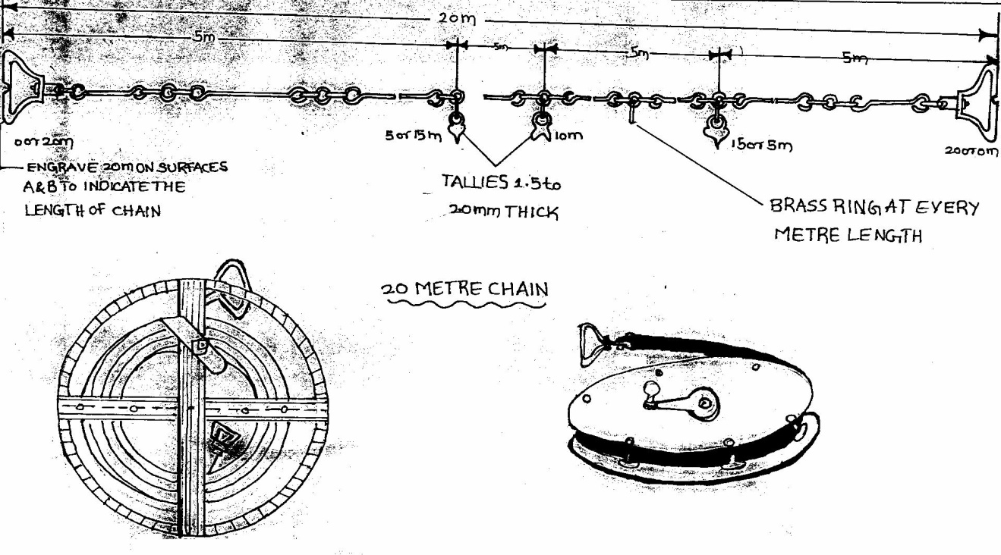

b) Tapes:

The following are the various types of tapes

- Cloth tape

- Metallic tape

- Steel tape

- Invar tape

Among the above, metallic tapes are widely used in surveying. A metallic tape is made of varnished strip of waterproof line interwoven with small brass, copper or bronze wires. These are light in weight and flexible and are made 2m, 5m 10m, 20m, 30m, and 50m.

- Arrows:

Arrows are made of good quality hardened steel wire of 4 mm diameter. The arrows are made 400 mm in length, are pointed at one and the other end is bent into a loop or circle
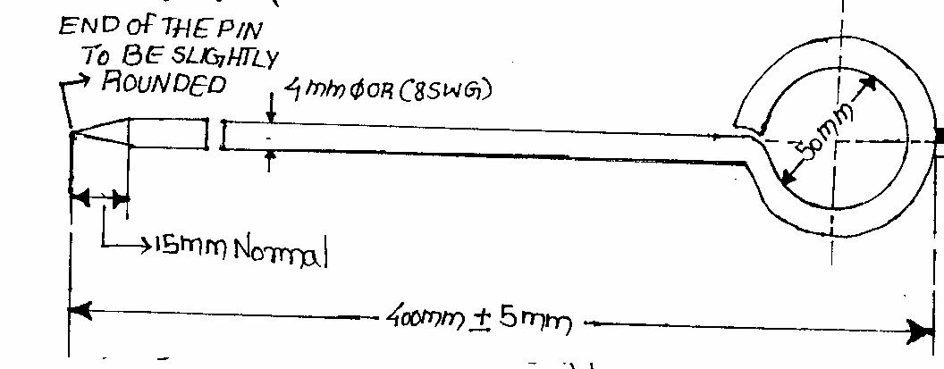

- Ranging rods:

Ranging rods are used to range some intermediate points in the survey line The length of the ranging rod is either 2m or 3m. They are shod at bottom with a heavy iron point. Ranging rods are divided into equal parts 0.2m long and they are painted alternately black and white or red and white or red, white and black. When they are at considerable distance, red and white or white and yellow flags about 25 cm square should be fastened at the top.

- Cross staff: The simplest instrument used for setting out a right angle. The common forms of cross staff are:
 |  | Open cross staff |  |  | French cross staff |  |  | Adjustable cross staff
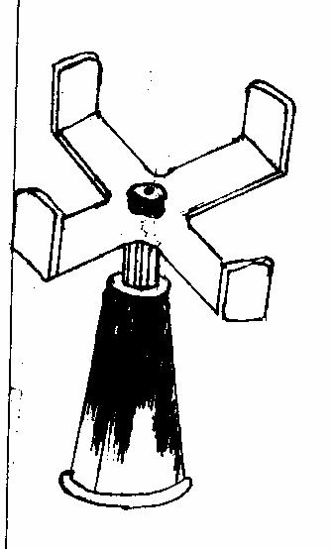
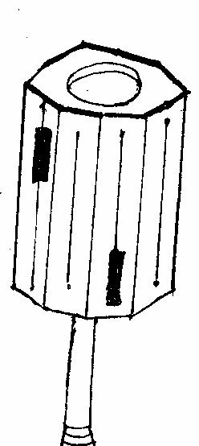
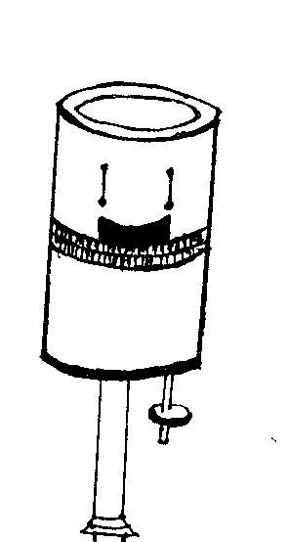

- OFFSET ROD:

The offset rod is used for measuring the off set of short lengths. It is similar to a ranging rod and is usually of 3m lengths.

- PEGS:

These are rods made from hard timber and tapered at one end, generally 25mm or 30mm square and 150mm long wooden pegs are used to mark the position of the station on.

- PLUMB BOB:

While chaining along sloping ground, a plumb bob is required to transfer the points to the ground.
 | OFFSET ROD |  |  | PEGS |  |  | PLUMB BOB
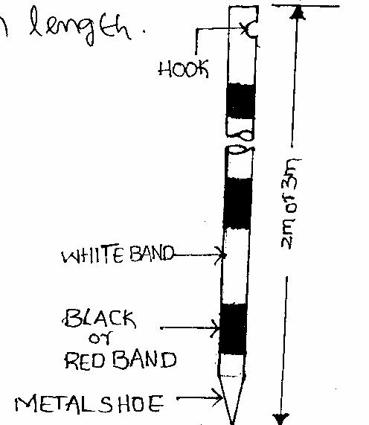
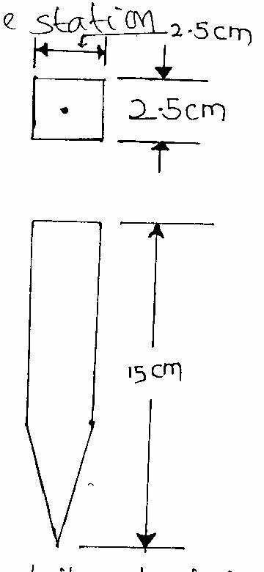
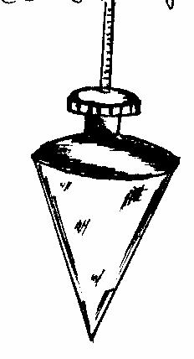

PRACTICING UNFOLDING AND FOLDING OF A CHAIN

OBJECTIVE: To learnt the technique of unfolding and folding of a metric chain.

INSTRUMENTS: Metric chain

PROCEDURE:

UNFOLDING:

- Remove the strap of the folded chain and take both the handles in the left hand and hold the remaining portion of the chain in the right hand.
- Holding both the handles in the left hand, throw the remaining portion o f the chain in the forward direction on the ground.

- Now the follower stands at the starting station by holding one handle and directs the leader to move forward by holding the other handle until the chain is fully stretched.

FOLDING:

- Bring the two handles together on the ground by pulling the chain at the center.

- Commencing from the center two pairs of links are taken at a time with the right hand and placed alternatively in both directions in the left hand.

- When the chain is completely folded the two brass handles will appear at the top.

- Now tie the chain with leather strap.

EXPERIMENT NO. 01

CHAINING A LINE BY DIRECT RANGING

Surveyor: | Date:
Helpers: | Time:

OBJECTIVE: To measure the distance between two points on a level ground by ranging.

INSTRUMENTS:
Chain 20m / 30m | 1 No. | Arrows | 10 Nos.
Ranging rods | 04 Nos. | Pegs | 2 Nos.
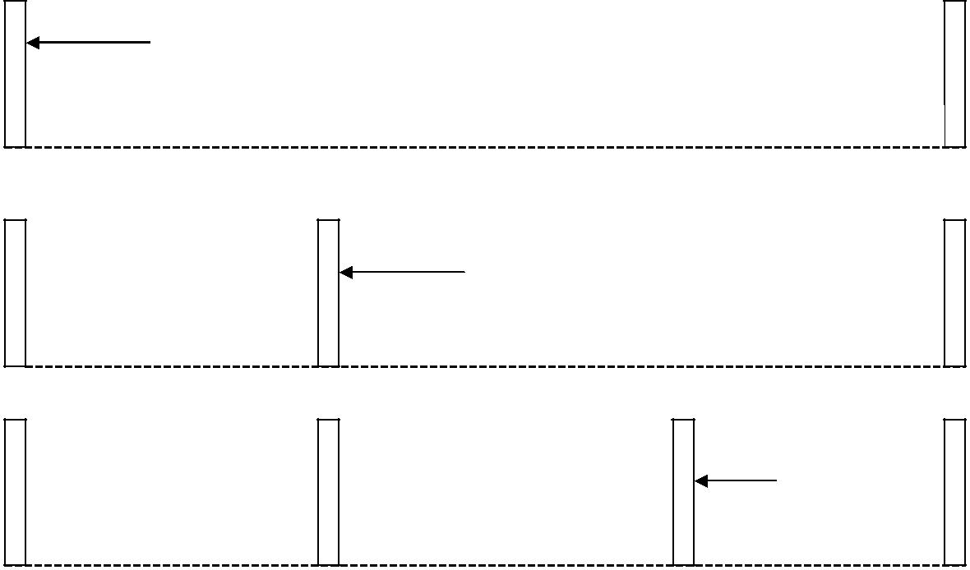

RANGING ROD

A

B

RANGING ROD

A |  | C |  | B

RANGING

ROD

A |  | C |  | D |  | B

PROCEDURE:

- Fix the ranging rods at the two given stations, where pegs are already driven on the ground.

- The follower stand behind station A and directs the leader, with ranging rod to come in line with AB by signals of ranging

- When the ranging rod comes in the line of AB the follower directs the leader to fix the ranging rod in position.

- Let the intermediate point be C which should be less than 20m / 30 m .

- Now the leader taken another ranging rod and stands between A and B about 2/3 distance from A

- The follower directs the leader to come in line of AB by using signals of ranging.

- As and when the point is located in the line of AB the follower instructs to fix the ranging rod in position.

- Let the other intermediate position be D which is less than 20 m / 30 m from B

- Now A, B, C and D are in one line.

Now the leader and follower measure the distance by measuring along A, C, D, B.

RESULT: The distance between AB = __________ meter.

FIELD APPLICATION:

- It can be extended to measure the lengths of more than two chain lengths.

- By measuring the boundaries of given traverse the areas can be calculated.

- The features can be located either by measuring oblique or perpendicular offset from the chain line.

EXPERIMENT NO. 02

 |  | CHAINING A LINE BY INDIRECT RANGING
 | Surveyor: |  | Date:
 | Helpers: |  | Time:

OBJECTIVE: Chaining a line when a hill or high ground intervenes preventing Intervisibility of ends of line.

INSTRUMENTS:

Chain 20m / 30m 1 No. Arrows 10 Nos.

Ranging rods 04 Nos.
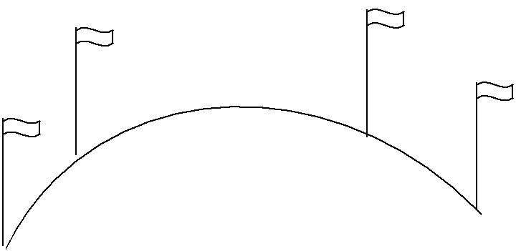

 |  |  |  |  |  |  | N
A | M |  |  |  |  |  |  |  |  | B
A |  | M |  |  |  |  |  | N
 |  |  | M₃
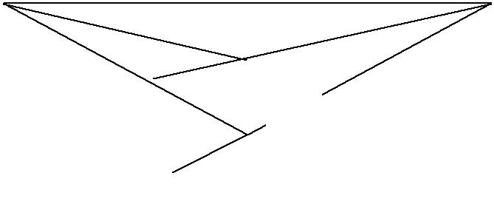
M₂ ^{N3}
N₂
PROCEDURE: _{M1}

- Fix the two ranging rods at the given stations A and B which are not intervisible due to raising ground.

- Select two intermediate points M₁ and N₁ such that from each point both A and B are visible.

- The person at M₁ directs the person at N₁ to move to a new position N₂ in line with M₁B.
- The person at N₂ then directs the person at M₁ to move to a new position M₂ in line with N₂A.
- The person at M₂ directs the person at N₂ to a new position N₃ in line with M₂B.
- The person at N₃ directs the person at M₂ to a new position M₃ in line with N₃A.
- The process is repeated till the points M and N are located in such a way that M finds the person at N in line with AB and the person at N finds the person at M in line with AB.

- After fixing the points M and N, other points are also fixed by direct ranging and the length of the line is measured.
Result:
Length of AM | = | ____ meter.
Length of MN | = | ____ meter.
Length of NB | = | ____ meter.

Therefore distance of AB = distance AM + distance MN + distance NB

EXPERIMENT NO. 03

MEASUREMENT OF AREA BY CHAIN TRIANGULATION

Surveyor: | Date:
Helpers: | Time:

OBJECTIVE: To measure the area of the given field by chain triangulation..

INSTRUMENTS:
Chain 20m / 30m |  |  |  | 1 No. |  | Arrows | 10 Nos.
Ranging rods |  |  |  | 6 Nos. |  | Pegs | 5 Nos.
SKETCH: |  |  |  |  | D
 |  |  |  |  |  | C
 | E |  |  |  |  | C
 |  | A |  |  |  | B
PROCEDURE:
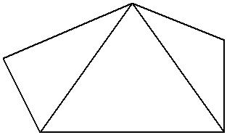
- Let ABCDE be the given field whose area is to be measured, fix the pegs at A, B, C, D & E.

- Divide area into three triangles ADE, ABD and BCD by joining AD and BD.

» Measure the lengths AB, BC , CD, DE, EA, AD and BD.

- Calculate the area of the triangles.

- The sum of the areas of the three triangles is the area of the given field.

FORMULA:

Area of the triangle ∆ = √ s (s-a) (s-b) (s-c)

Where S = (a + b+ c) / 2

A, b, c, are the sides of the triangle.

RESULT:

The area of the given field = _______ Square meter.

EXPERIMENT NO. 04

CHAIN TRIANGULATION AROUND A BUILDING

 | Surveyor: |  |  |  |  |  | Date:
 | Helpers: |  |  |  |  |  | Time:
OBJECTIVE: To chain around |  |  |  | the building to cover small area by chain triangulation
INSTRUMENTS:
 | Chain 20m / 30m |  |  | 1 No. |  |  |  |  |  | Arrows |  |  |  |  |  | 10 Nos.
 | Ranging rods |  |  | 4 Nos. |  |  |  |  |  | Pegs |  |  |  |  |  | 4 Nos.
 | Tape 20m/30m |  |  | 1 No |  |  |  |  |  | Cross staff |  |  |  |  |  | 1No
SKETCH:
 |  |  |  |  |  |  |  |  |  | C
 |  |  |  |  |  |  |  |  |  |  |  |  | TIE LINE
 |  |  | CHECK
 |  |  | LINE |  |  |  | e
 |  |  | LINE |  |  |  | e |  |  |  |  |  |  |  | f
 |  |  |  |  |  |  | e |  |  | S |  |  |  |  | f
 |  |  |  |  |  |  |  |  |  | S |  |  |  |  | R
 |  |  |  |  |  |  |  |  |  | P |  |  |  |  | Q
 |  | A |  |  |  |  |  |  |  |  |  |  |  |  |  |  |  | B
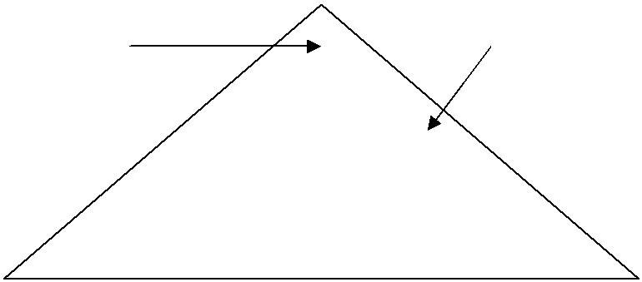
D

PROCEDURE:

- Select three survey stations A, B and C such that from each survey station the other two stations are visible..

- Fix the ranging rods at A, B and C

- Fix the intermediate stations along the chain line AB, BC and CA by ranging.

- Measure the offsets of the corners of the building either perpendicular or oblique.

- Each point requires two measurements from two definite reference points on the same line or from two adjacent chain lines.

- Measure the points which are very far away from the main chain lines from tie line i.e , the corners points of building R and S. Measure the check line CD.

RESULT: From the recorded measurements of the building area is plotted.

NOTE: The student should prepare a layout of the given area covering building roads etc.

TOPIC – 2

COMPASS SURVEYING

- Familiarity with instruments used in compass surveying – prismatic compass.

- Setting up the compass – observation of bearings.

- Traversing with prismatic compass and chain calculation of included angles and check.

- Traversing with prismatic compass and chain closed traverse covering the given area recording.

- Traversing with prismatic compass and chain open traverse and recording.

FAMILIARITY WITH INSTRUMENTS USED IN COMPASS

SURVEYING PRISMATIC COMPASS

OBJECTIVE: To identify different parts of prismatic compass and to know their functions

SKETCH:


 |  |  | Parts List
1. | Compass Box | 2. | Magnetic Needle | 3. | Graduated Ring
4. | Pivot | 5. | Objective Vane | 6. | Eye Vane
7. | Adjustable Mirror | 8. | Spring Brake | 9. | Brake Pin
10. | Lifting Lever | 11. | Lifting Pin | 12. | Prism
13. | Focusing Stud | 14. | Glass Cover | 15. | Prism Dust Cap
16. | Sun Glasses

DESCRIPTION OF INSTRUMENTS

COMPASS BOX: It is a circular box of diameter 85 to 110 mm having pivot at the center and covered with plain glass at top.

MAGNETIC NEEDLE: It facilitates in taking the bearings of survey lines with reference to the magnetic north.

GRADUATED RING: The bearings are marked inverted on the graduated rings from 0° to 360° in a clockwise starting 0° from south.

PIVOT: Magnet is freely held with this.

OBJECT VANE: It consists of prism with a sighting slit at the top. The

prism magnifies and erects the inverted graduations.

BRAKE PIN: It is pressed to stop the oscillations of the graduated ring.

LIFTING PIN: On pressing it brings the lifting lever into action.

COLOUR GLASSES: Red and blue glasses are provided with the prism to sight luminous objects.

EXPERIMENT NO. 05

SETTING UP THE COMPASS – OBSERVATION OF BEARINGS

Surveyor: Date:

Helpers: | Time:

OBJECTIVE : To perform station adjustments and to observe magnetic bearings using a prismatic compass.

INSTRUMENTS: Prismatic compass, tripod and ranging rods.

SKETCH:

A
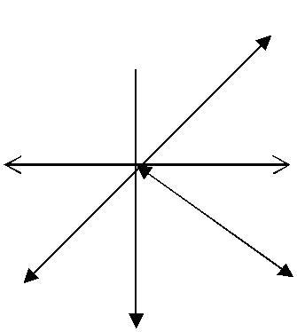
N

O

C

B

S

PROCEDURE:

The following station adjustments are to be done at each station where the compass is set up.

- CENTERING:

  - Centering is the process of keeping the prismatic compass over the station point.

  - By moving the legs of the tripod suitably, centering will be done.
  - Centering is checked by dropping a stone so that it falls on the top of the peg.

- LEVELLING:

  - Leveling is the process of making the compass exactly horizontal.

  - Level the compass by means of ball and socket arrangements.
  - When the compass is leveled, the aluminum ring swings freely.

- FOCUSSING:

To adjust the height of the prism so that the observations can be read clearly.

- OBSERVING BEARINGS:

  - Set up the prismatic compass over station ‘O’ and perform station adjustments.

  - Rotate the compass till the line of sight bisects the object at ‘A’.
  - Read the graduated ring through prism. The reading directly gives the magnetic bearing of ‘OA’ in whole circle bearing system.

  - Follow the same procedure to observe the magnetic bearings ‘OB’ ‘OC’ also.

- TABULAR FORM:

Sl.No. | Station | Sighted to | W.C.B.

EXPERIMENT NO. 06

TRAVERSING WITH PRISMATIC COMPASS AND CHAIN –

CALCULATION OF INCLUDED ANGLES

 | Surveyor: |  | Date:
 | Helpers: |  | Time:
OBJECTIVE: |  | To find the bearings of various station points and to
calculate the included angles.

INSTRUMENTS: Prismatic compass, Tripod, Ranging rods, etc.

SKETCH: | A
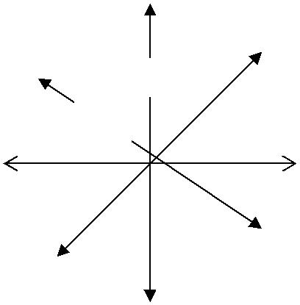
N

O

C ^{B}
S

- Let ‘O’ be the instrument station selected from which all other points are visible.

- Complete all station adjustments like setting, centering and leveling accurately.

- Sight the object ‘A’ looking through the prism vane, while the object vane is directed towards the object.
- Observe the bearing by looking through the prism. Enter the readings in the tabular form.
- Repeat the process at all objects stations B,C,D etc and enter the readings.

FORMULA:
Included angle: bearing of 2nd line bearing of first line.
(If the value is more than 180º than subtract the value from 360º ).

TABULAR FORM

Sl.No. | Station | Sighted to | W.C.B.
* * *

EXPERIMENT NO. 07

TRAVERSING WITH PRISMATIC COMPASS AND CHAIN – CLOSED TRAVERSE COVERING THE AREA (Given) RECORDING

Surveyor: Date:

Helpers: | Time:

OBJECTIVE : To conduct compass survey along the closed traverse.

INSTRUMENTS: Prismatic compass, chain, ranging rods.
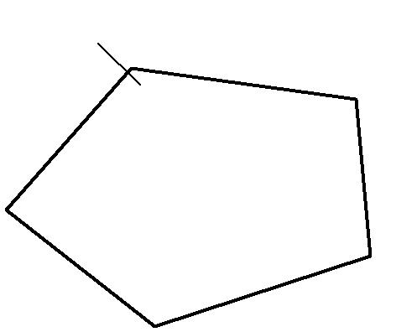
N E

SKETCH: | D

A

PROCEDURE:

C

B

- Fix the closed traverse A B C D E .

- Set up the compass at the station ‘A’.

- Perform the temporary adjustments.

- Sight the object at ‘B’ and note down the FB of line AB and measure the distance.

- Sight the object at E and note down the BB of EA.

- Sight the instrument to station ‘B’ performs all the temporary adjustments.

- Sight the object at ‘A’ and take the ‘BB’ of ‘AB’.

- Take ‘FB’ of ‘BC’ and measure the length of ‘BC’.

- Check whether the difference of ‘FB’ and ‘BB’ is 180º or not, at all stations.

- Continue the same process all at other stations.

TABULAR FORM FOR CLOSED TRAVERSE

Sl.No. | Line | Length | F.B. | B.B | Remarks

FORMULA: Included angle = B.B of previous line – F.B of next line.

CHECK: The sum of the included angles should be equals to (2n-4) x 90º Where ‘n’ is number of sides of the traverse.

EXPERIMENT NO. 08

TRAVERSING WITH PRISMATIC COMPASS

AND CHAIN – OPEN TRANRSE AND RECORDING

Surveyor: Date:

Helpers: | Time:

OBJECTIVE: To perform the compass survey in open traverse formed by series of connected straight lines.

INSTRUMENTS: Prismatic compass, tripod, tape, chain, arrows and ranging rods.

SKETCH:
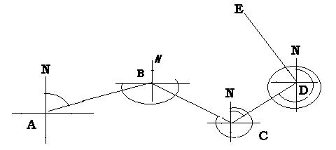

PROCUDURE:

- Set the instrument at the starting station ‘A’ and perform all the necessary adjustments.

- Sight the next station ‘B’, take fore bearing of ‘AB’ and measure the distance ‘AB’.

- Take F.B of ‘AE which provides check; similarly bearing of any line AC, CE, … etc. also provides the check.

- Shift the instrument to subsequent station ‘B’. After fixing the instrument sight the previous station ‘A’ and observe the reading, which gives the B.B. of AB.

- Sight next station ‘C’ observe F.B of BC and measure the distance BC.

- Locate the details surrounding the traverse station if necessary, by taking bearings or lengths or both from chains line.

- Repeat the process at every station.

- It is to be noted that first and last stations have only fore bearing and back bearings respectively.

- Take Back bearings of the first point from the last point.

- Enter the reading in a tabular form.

Sl.No. | Line | Length | F.B. | B.B. | Remarks
1. | AB
2. | BC
3. | CD
4. | DE

CHECK: The difference between Fore bearing and back bearing of each line should be 180º, if no local attraction exists at either station.

TOPIC - 3

PLANE TABLE SURVEYING

1 . | I n t r o d u c t i o n t o p l a n e t a b l e e q u i p m e n t a n d
 | a c c e s s o r i e s .
2 . | S e t t i n g o f t h e p l a n e t a b l e a n d p l o t t i n g a
 | f e w o b j e c t s ( p o i n t s ) b y r a d i a t i o n m e t h o d
3 . | P l o t t i n g b u i l d i n g a n d o t h e r f e a t u r e s o f t h e
 | c a m p u s b y i n t e r s e c t i o n m e t h o d .
4 . | T r a v e r s i n g a n a r e a b y p l a n e t a b l e .
5 . | C a l c u l a t i n g t h e a r e a f o r t h e g i v e n l a n d a n d
 | m a r k i n g p l o t s b y u s i n g p l a n e t a b l e .

INTRODUCTION TO PLANE TABLE EQUIPMENTS AND ACCESSORIES

OBJECTIVE: Study of plane table equipments and accessories.

INTRODUCTION TO PLANE TABLE:

Plane table surveying is a graphical method of surveying in which field work and plotting are done simultaneously in the field.

The plain table consists of the following:

- Drawing board mounted on a tripod

- Straight edge called an alidade.

THE DRAWING BOARD:

The board is made of well- seasoned wood and varies in size from 40cm x 30 cm to 75cm x 60cm or 50 – 60 cm square.

The Alidade:

The alidade consists of metal or box wood straight edge or ruler about 50cm long. The be welled edge of the alidade is called the fiducially edge.

Accessories to the plane table

- Trough compass
- U – frame or plumbing fork
- Water proof cover.
- Spirit level or level tube
- Drawing sheet
- Pencil or eraser

Trough compass: The compass is used to mark the direction of the meridian on the paper.

U- frame or Plumbing fork:

U frame with a plumb bob used for centering the table.

Water Proof Cover:

Water Proof cover protects the sheet from rain.

Spirit level or level tube:

A level tube is used to level the plane table.

Drawing sheet:

The drawing sheet is fixed on the top of the drawing board.
Pencil and eraser:

A pencil is used for constructing lines and eraser is used for erasing lines after completion of the plan.

SETTING UP THE PLANE TABLE

The setting up the plane table includes the following three operations.

- Centering the plane table

- Leveling the plane table
- Orientation of plane table

CENTERING THE PLANE TABLE:

The table should be set up at a convenient height for working say about 1m. The legs of tripod should be spread well apart and firmly fixed in to the ground. The table should be approximately leveled by tripod legs and judging by the eye.

Then the operation of centering is carried out by means of U-frame and plumb bob. The plane table is exactly placed over the ground station by U-frame and plumb bob.

LEVELING THE PLANE TABLE:

The process of leveling is carried out with the help of level tube. The bubble of level tube is brought to center in two directions, which are right angles to each other. This is achieved by moving legs.

ORIENTING THE TABLE:

The process of keeping the plane table always parallel to the position, which is occupied at the first station, is known as orientation. When the plane table is oriented, the lines on the board are parallel to the lines on the ground.

EXPERIMENT NO. 09

SETTING OF THE PLANE TABLE AND PLOTTING A FEW OBJECTS

(POINTS) BY RADIATION METHOD

SURVEY LAB: DATE:

OBJECTIVE: Setting up the plane table and plotting a few objects by radiation method.

INSTRUMENTS:

- Plane table

- Tripod

- Alidade

RADIATION: The plane table is set up over only one station from which the whole traverse can be commanded. It is suitable for survey of small areas.
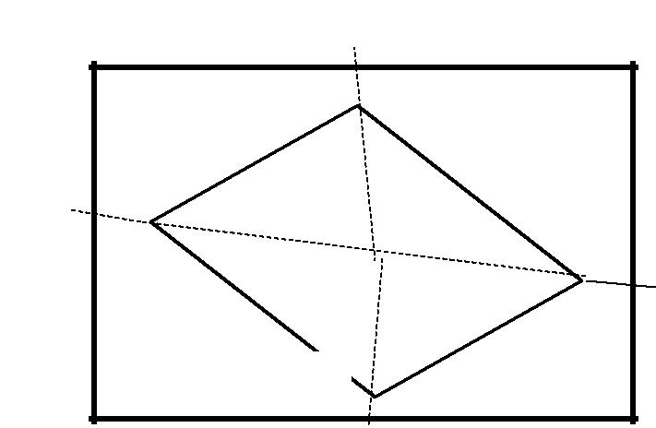
SKETCH: |  | A
 |  |  | a
D | d | o
 |  | o | b
 |  |  | B
 |  | c

PROCEDURE:

- Select a point “O ” so that all points to be located are visible from it.

- Set up the table at “O”, level it, and do centering.

- SELECT A POINT “O” on the sheet so that it is exactly over station “O” on the ground.

- Mark the direction of the magnetic meridian

- Centering the alidade on “O” BISECT the objects of traverse A, B, C and D.

- Measure the distances OA, OB, OC and OD and plotted to convenient scale to locate a, b, c and d respectively

- Join the points a, b, c and d on the paper.

EXPERIMENT NO. 10

PLOTTING BUILDING AND OTHER FEATURES OF THE

COMPASS BY INTERSECTION METHOD

SURVEY LAB: DATE:

OBJECTIVE: Plotting building and other features of the compass by Intersection method.

INSTRUMENTS:

- Plane table

- Tripod
3) Alidade |  | B
3) Alidade | A | B
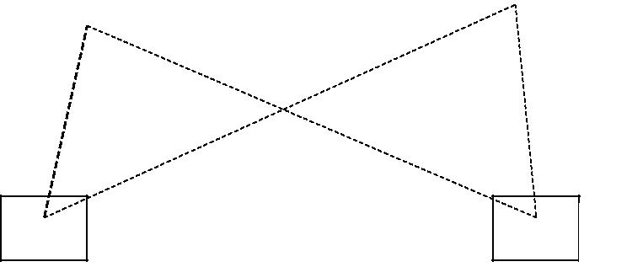
FIGURE

P | Q

PROCEDURE:

- Select two points P and Q such that the points (building corners) to be plotted are visible from their stations.

- Set the table on P and locate on the sheet.

- Pivot on P bisect Q draw a ray.

- Measure the distance PQ and locate Q on the sheet to a convenient scale.

- Now pq is known as the base line.

- Pivot ‘p’ bisects the inaccessible objects A and B (building corners) and draw rays.

- Shift the table to ‘a’ such that q is over Q and do temporary adjustments.

- Place the alidade along qp and the rotate the table till p is bisected clamp table.

- Pivot on q bisect the objects A and B and draw rays.

- The instruction of rays drawn from P and Q will give the points a and b.

11) To check the accuracy measured AB and compare with plotted distance ab.

- The same procedure is applied for other features of the campus. each point is bisected from two stations.

EXPERIMENT NO. 11

TRAVERSING ON AREA BY PLANE TABLE

SURVEY LAB: DATE:

OBJECTIVE: Traversing method is used for running survey lines of a closed or open traverse.

INSTRUMENTS: 1. Plane table 2. Tripod 3. Alidade
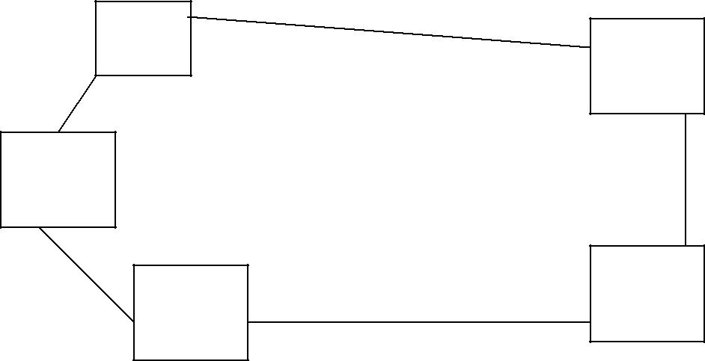

FIGURE

A

E

B

D

PROCEDURE:

C

- Select the traverse stations A,B,C,D,E etc on the ground.

- Set the table on starting station ‘a’ and perform temporary adjustments.
- Mark the magnetic meridian.

- Locate A on the sheet as ‘a’.

- Pivot on ‘a’ bisect the next station B and draw a ray

- Measure the distance AB and locate ‘b’ on the sheet with a suitable scale.

- Shift the table to next station B, set the table over B, and do temporary adjustments.
- Place the alidade along ‘ba’ and bisect A for doing orientation of plane table.

- Pivot on b bisect c draw a ray

- Measure the distance BC and locate ‘c’ on the sheet with the suitable scale.

- Report the same procedure at every successive station until the traverse is completed.

NOTE: by using radiation method, intersection and traversing methods we can locate the points on the paper, which were already on the ground. By using algebraic formulae, we can calculate the area of the given land.

FORMULAE:

- Area of a triangle = ½ * base *height

- Area of a square = side * side

- Area of a rectangle = length * breadth

- Area of a trapezium = ½ * (a + b) * h

A, b are the parallel sides . h is the distance between parallel sides.

TOPICS - 4

LEVELLING

- Study of dumpy level and leveling staff

- Temporary adjustments of dumpy level.

- Taking out levels of various points and booking in a level field book.

- Differential or fly leveling-reduced levels by H-I method rise and fall method.

- Differential leveling involving invert levels-reduction by H-I method, rise, and fall methods.

☺ ☺

STUDY OF DUMPY LEVEL AND LEVELLING STAFF

OBJECTIVE: Study of components of dumpy level and leveling staff.

INSTRUMENTS: A level and leveling staff.

FIGURE:

3

4
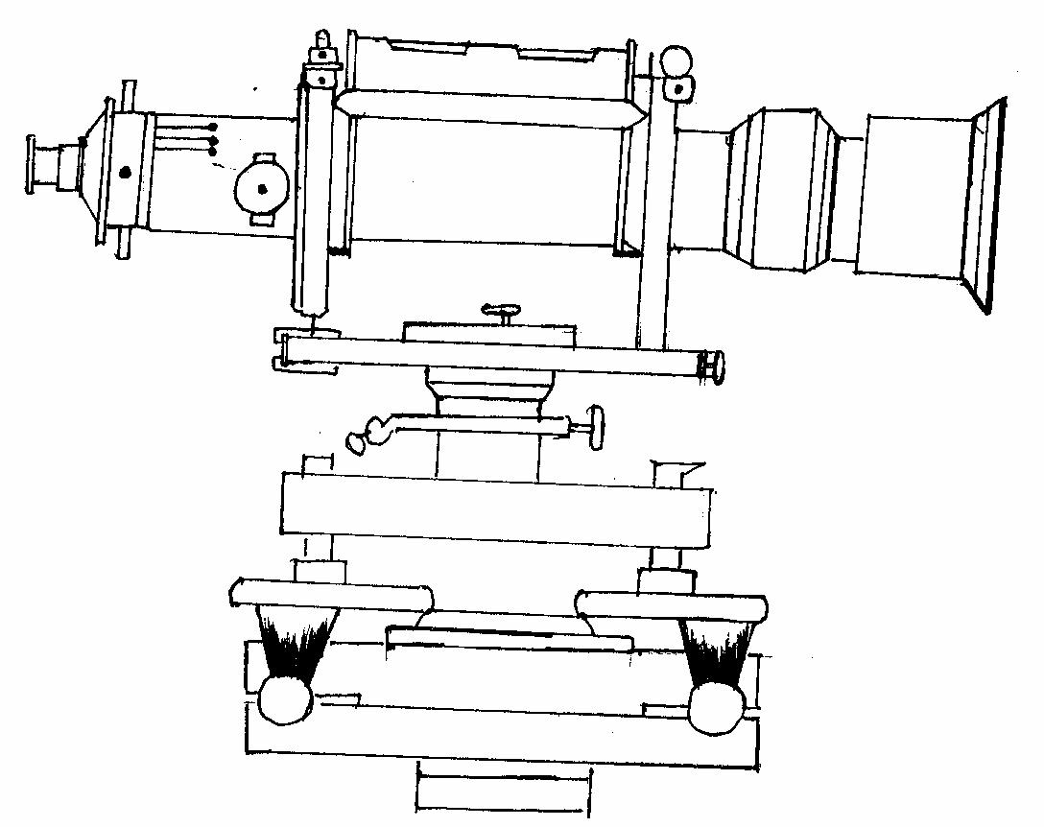
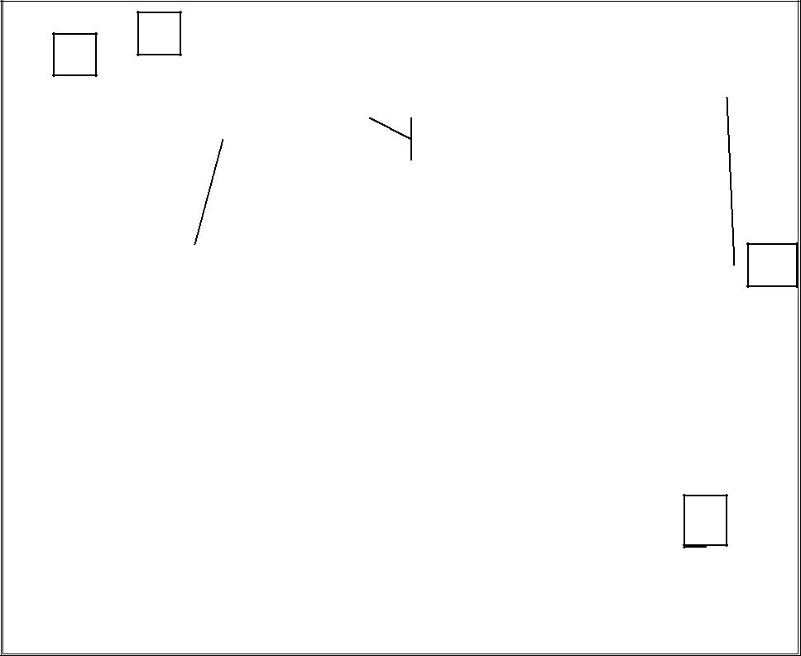

2

5

6

1

1. | Leveling head | 4. | Diaphragm
2. | Telescope | 5. | Focusing screw
3. | Eye-piece | 6. | Ray-shade

The Major Components Of A Dumpy Level

TELESCOPE:

It contains of two metal tubes, one of which slides within the other one-tube carries the object glass and the second one carries eyepiece and diaphragm.

FOCUSSING SCREW:

The telescope is focused by turning the focusing screw either forward or backward.

BUBBLE TUBES:

The telescope is attached with two bubble tubes. One is longitudinal and the other is cross bubble tube. These two are placed at right angles to each other.

DIAPHRAGM:

It carries cross hairs.

TRIBRACH & TRIVET:

The telescope with vertical spindle is supported by two parallel triangular plates. The upper plate is called tribrach and the lower plate is called trivet

FOOT SCREWS:

By turning the foot screws, the tribrach can be raised or lowered to bring the bubble to the center of its run.

LEVELLING STAFF:

THE LEVELLING STAFF:

It is used for measuring the vertical distance of the points above or below the horizontal line of sight. The different staves in use are

1. Sop with telescope staff 2. Folding staff 3. Solid staff 4. Target staff

SOP WITH TELESCOPE STAFF:

It is usually arranged in three telescopic lengths. The staff is 4m long when fully extended. The top length 12.5m is solid slides into the central box of length 12.5m, which again slides in the bottom box of 1.50m long. The staff is provided with brass spring catches to keep the extended length in position.

The meter numerals are marked on the left side and are pointed in red. The decimeter numerals are marked on the right side and are pointed in black.
The background is painted in white. The smallest division on this staff is 5mm. The graduations are marked erect and are seen inverted when viewed through the telescope.

FOLDING STAFF:

It is made of well-seasoned timber such as deodar, blue pine or aluminum. It is 4m long, 75mm wide, 18mm thick. It has two lengths of 2m each which are connected at the middle by a hinge so that the upper portion can be folded over the lower one.
The minimum division on the staff is 5mm.

The lengths of meter in numerals are marked on the left and painted in black. The entire background is painted in white. The graduations are inverted and hence when viewed through the telescope, they appear erect.

SOLID STAFF:

It consists only one length and is usually 3m long. It is also graduated in divisions of 5mm. This is used for precise leveling work.

TARGET STAFF:

It consists of two lengths, one sliding over the other. It is graduated from top downwards. The target is equipped with vernier, which is adjusted by the staff man. The target is to be moved along the rod until its center is bisected by the line of sight. The target is then clamped and reading is taken. Target staves are used when the sights are long, say more than 100m.

******

TEMPORARY ADJUSTMENTS OF DUMPY LEVEL

OBJECTIVE: To obtain accurate results of leveling.

INSTRUMENTS: Dumpy level

PROCEDURE:

Temporary adjustments are to be made at each setup of the instrument. The following are the temporary adjustments to be made.
  - Setting up of the level
  - Leveling up
  - Elimination of parallax.

- SETTING UP OF THE LEVEL

- Release the clamp screw of the instrument

- Hold the instrument in the right hand and fix it on the tripod by turning round only the lower part with the left hand.
- Screw the instrument firmly.

- Bring all the foot screws to the center of its run.

- Spread the tripod legs well apart.

- Fix any two legs firmly into the ground by pressing them with the hand.

- Move the third leg to the right or left until the main bubble is approximately in the center.

- Then move the third leg in or out until the bubbles of the cross-level is approximately in the center.

- Fix the third leg firmly when the bubbles are approximately in the centers of their run.

2. LEVELLING UP

- Place the telescope parallel to a pair of foot screws.

- Bring the bubble to the center of its run by turning the foot screws equally either both inwards and both outwards.
- Turn the telescope through 90º so that it lies over the third foot screw.

- Turn this third foot screw so that the bubble corners to the center of its run.

- Bring the telescope back to the original position without reversing the eye-piece and object glass.
- Repeat the above operations until the bubble remains in the center of its run in both the positions.
- Turn the telescope through 180º and check whether the bubble remains central.

3. ELIMINATION OF PARALLOX:

- Remove the lid from the object glass.

- Hold a sheet of white paper in front of the object glass.

- Move the eyepiece in or out until the cross hairs are distinctly visible.

- Direct the telescope towards the staff.

- Turn the focusing screw until a clear and sharp image in formed in the plane of the cross hairs.

TABULAR FORM FOR HEIGHT OF INSTRUMENT (H.I) METHOD

 |  | Readings |  |  |  | Height of | Reduced | Remarks
Station |  |  |  |  |  | Height of | Reduced
Station | Back |  | Inter |  | Fore | Instrument | Level
 | sight |  | Sight |  | Sight

H.I = R.L of B.M + B.S

R.L of other station points = H.I – I.S or F.S ARITHMATICAL CHECK:

Σ B.S – Σ F.S = Last R.L – First R.L

FOR RISE AND FALL METHOD

 |  | Readings
Station |  |  |  | Rise | Fall | R.L | Remarks
Station | Back | Inter | Fore
 | sight | Sight | Sight

ARITHMATICAL CHECK:

Σ B.S – Σ F.S = Σ Rise – Σ Fall = Last R.L. – First R.L

EXPERIMENT NO. 12

TAKING OUT LEVELS OF VARIOUS POINTS AND BOOKING IN

A LEVEL FIELD BOOK

SURVEYOR: |  | DATE:
HELPER: |  | TIME:

OBJECTIVE: Taking the levels of various points with Single setup, booking in a level field book.

INSTRUMENTS: 1. Dumpy level 2. Leveling staff.

PROCEDURE:

- Set the level at a convenient point.

- Perform the temporary adjustments.

- Hold the staff vertically over the Benchmark, Observe the staff reading and write in the B.S column of the field book.

- Hold the staff at other points and note the staff reading in the I.S column of the field book.

- Hold the staff on the last point and enter the staff reading in the F.S column of the field book.

- Find R.L. of all the points by both the methods.

- Apply arithmetical check.

EXPERIMENT NO. 13

DIFFERENTIAL OR FLY LEVELLING – REDUCE LEVELS BY H.I METHOD AND RISE AND FALL METHOD
SURVEYOR: |  | DATE:
HELPER: |  | TIME:

OBJECTIVE: To find the difference in elevation between two points.

INSTRUMENTS: 1. Dumpy level 2. Leveling staff.

FIGURE:
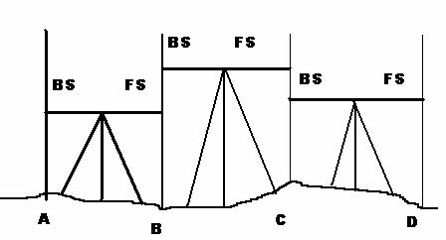

PROCEDURE:

- Let A and B be the two given points whose difference is elevation is to be found.

- Set the level at a convenient point O₁ carryout temporary adjustments and take B.S on A

- Take FS on the Point C

- Shift the instrument to point O2 and perform temporary adjustments.

- Take B.S on C.

- Take F.S. on D.

- Shift the instrument to point O₃ and perform temporary adjustments.

- Take B.S on D

- Take F.S on B.

- Find the difference in elevation between A and B by both the methods.

Result: Difference in elevation between A and B = ……………

EXPERIMENT NO. 14

DIFFERENTIAL LEVELLING INVOLVING INVERT LEVELS REDUCTION BY H.I AND RISE AND FALL METHODS
SURVEYOR: |  | DATE:
HELPER: |  | TIME:

OBJECTIVE: To find the levels of certain points which may lie above the line of collimation.

THEORY: When the point under observation is higher than the line of sight, staff should be kept inverted on the overhead point keeping the foot of the staff touching the point, and reading should be taken and recorded in the field book with a negative sign indicating invert level.

INSTRUMENTS: 1. Dumpy level 2. Leveling staff.

PROCEDURE:

- Setup the instrument at a convenient point and take the B.S on the benchmark.

- Place the staff in the inverted position at the required staff stations, which are lying above the line of collimation.
- Take the reading on the staff and note it in the field book with a negative sign.

- Calculate the R.L of the required staff station.

- Repeat the process for all invert staff readings.

- For all other points the procedure to find R.L is similar to that in the previous exercises.

TOPIC-5

THEODOLITE SURVEYING

- Study of Theodolite

- Measure of Horizontal angle between given lines

- Measurement of vertical angle

- Determining distance between two in accessible points by measuring horizontal angle
- Determining an height of object by measuring vertical angle

  - ☺

STUDY OF TRANSIT THEODOLITE

OBJECTIVE : To study different parts of transit Theodolite and Temporary adjustments.

EQUIPEMTNS: Transit – Theodolite

FIGURE
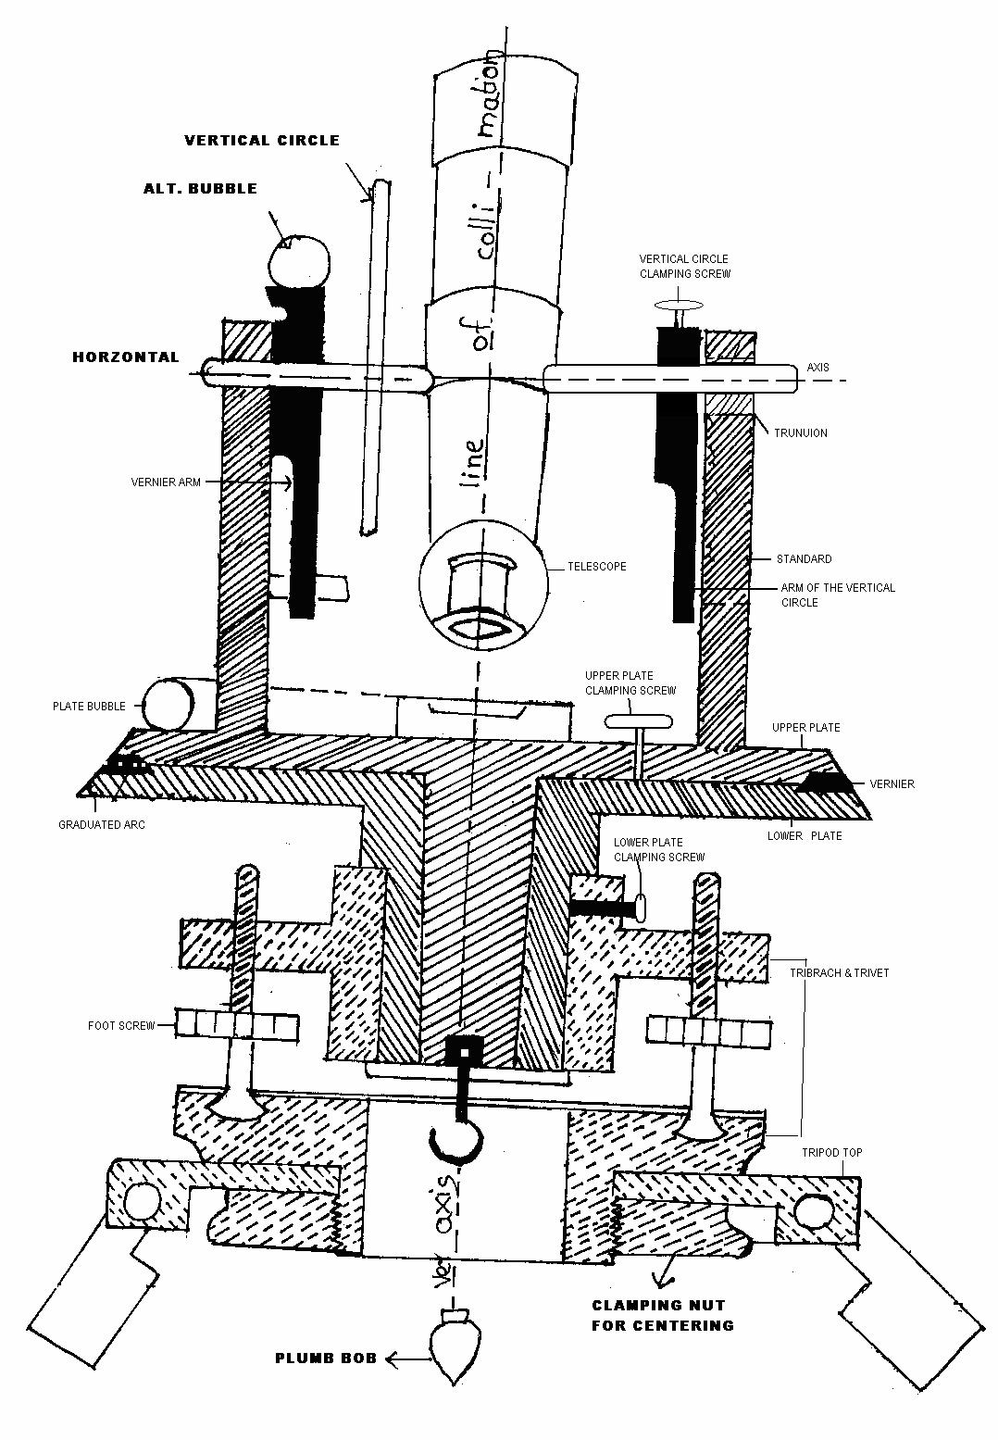

D E F I N I T O N A N D T E R M S

VERTICAL AXIS:

It is the axis about which the telescope can be rotated in a horizontal plane.

HORIZONTAL AXIS:

It is the axis about which the telescope can be rotated in a vertical plane.

LINE OF COLLINATION:

It is the imaginary line joining the intersection of the cross hairs of the diaphragm to the optical center of the object glass and its continuation.

AXIS OF THE TELESCOPE:

It is the line joining the optical center of the object glass to the center of the eye-piece.

AXIS OF THE LEVEL TUBE:

It is the straight line tangential to the longitudinal curve of the level tube at the center of the tube.

CENTERING:

The process of setting the theodolite exactly over the station mark is known as centering.

TRANSITING:

It is the process of turning the telescope in vertical plane through 180º about the trunnion axis.

DESCRIPTION OF EQUIPMENT:

TELESCOPE:
It consists of eye-piece , object glass and focusing screw and it is used to sight the object.
VERTICAL CIRCLE:
It is used to measure vertical angles.

LEVELLING HEAD:

It consists of two parallel triangular plates called tribrach plates. Its uses are
- To support the main part of the instrument.
- To attach the theodolite to the tripod.

LOWER PLATE:

It consists of lower clamp screw and tangent screw.

UPPER PLATE:

The upper plate is attached to the inner axis and it carries two verniers. It consists an upper clamp screw and tangent screws. These screws are used to fix upper plate with lower plate accurately.]

FOOT SCREWS:

These are used to level the instrument

PLUMB BOB:

It is used to center theodolite exactly over the ground station mark.

SWINGING THE TELESCOPE:

It means turning the telescope about its vertical axis in the horizontal plane. A swing is called right or left according as the telescope is rotated clockwise or counter clockwise.

FACE LEFT:

If face of the vertical circle is to the left side of the observer, then the observation of the angles taken is known as face left observation.

FACE RIGHT:

If the face of the vertical circle is to the right side of the observation, then the observation of the angles taken is known as face right observation.

CHANGING FACE:

It is an operation of bringing the face of the telescope from left to right and vice-versa.

TEMPORARY ADJUSTMENTS:

There are three temporary adjustments of a theodolite. These are
- Setting up the theodolite over a station.
- Leveling up.
- Elimination of parallax.

SETTING UP:

It includes two operations
- Centering a theodolite over a station: Done by means of plumb bob.

- Approximately leveling it by tripod legs only: Done by moving tripod legs radially or circumferentially.

LEVELING UP:

Having centered and approximately leveled the instrument, accurate leveling is done with the help of foot screws with reference to the plate levels, so that the vertical axis shall be truly vertical.
To level the instrument the following operations have to be done.

- Turn the upper plate until the longitudinal axis of the plate level is roughly parallel to a line joining any two of the leveling screws (A & B).

FIGURE:
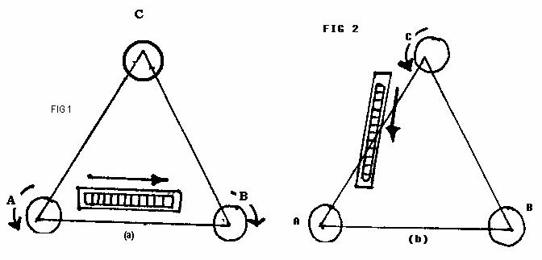

- Hold these two leveling screws between the thumb and first finger of each hand uniformly so that the thumb moves either towards each other or away from each other until the bubble comes to the center.

- Turn the upper plate through 90º i.e until the axes of the level passes over the position of the third leveling screw ‘C’.

- Turn this leveling screw until the bubble comes to the center.

- Rotate the upper plate through 90º to its original position fig(a) and repeat step(2) till the bubble comes to the center.

- Turn back again through 90º and repeat step 4 .

- Repeat the steps 2 and 4 till the bubble is central in both the positions.

- Now rotate the instrument through 180º. The bubble should be remaining in the center of its run, provided it is in correct adjustment. The vertical axis will then be truly vertical.

3. ELIMINATION OF PARALLAX:

Parallax is a condition arising when the image formed by the objective is not in the plane of the cross hairs. Unless parallax is eliminated, accurate sighting is not possible. Parallax can be eliminated in two steps.

- FOCUSSING THE EYE-PIECE:

Point the telescope to the sky or hold a piece of white paper in front of the telescope. Move the eyepiece in and out until a distant and sharp black image of the cross-hairs is seen.

- FOCUSSING THE OBJECT:

Telescope is now turned towards object to be sighted and the focusing screw is turned until image appears clear and sharp.

VIVA QUESTIONS:

- State any four uses of a theodoite?

- What is meant by face left and face right?

- What does swinging of telescope means?

- What is meant by transiting?

EXPERIMENT NO. 15

MEASUREMENT OF HORIZONTAL ANGLE BY REPETITION METHOD

OBJECTIVE: To measure a horizontal angle by repetition method.

THEORY: In this method, the angle is added several times mechanically and the value of the angle obtained by dividing the accumulated reading by the number of repetitions.

EQUIPMENTS USED: Transit thodolite, tripod and ranging rods(2no.s).

SKETCH: | P | Q
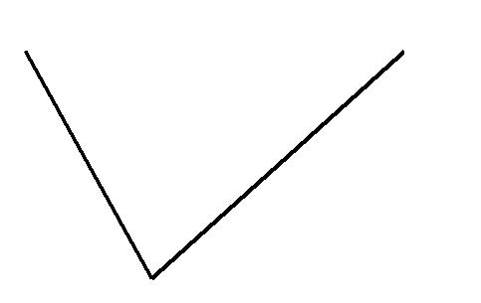

O

PROCEDURE:

- Set up the instrument over ‘O’ and level it accurately.

- With the help of upper clamp and tangent screw, set 0º reading on vernier ‘A’. Note the reading of vernier ‘B’.
- Release the upper clamp and direct the telescope approximately towards the point ‘P’. Tighten the lower clamp and bisect point ‘P’ accurately by lower tangent screw.
- Release the upper clamp and turn the instrument clock-wise towards Q. Clamp the upper clamp and bisect ‘Q’ accurately with the upper tangent screw. Note the readings of verniers ‘A’ and ‘B’ to get the values of the angle POQ.

- Release the lower clamp and turn the telescope clockwise to sight P again. Bisect P by using the lower tangent screw.
- Release the upper clamp, turn the telescope clockwise and sight Q. Bisect Q by using the upper tangent screw.
- Repeat the process until the angle measured (required number of times is 3). The average angle with face left will be equal to final reading divided by three.

- Change face and make three more repetitions as described above. Find the average angle with face right, by dividing the final reading by three.
- The average horizontal angle is then obtained by taking the average of the two angles with face left and face right.

Averagehorizontal | angle
Horizontal Angle

“ Sec ‘ Min

.o Deg. “ Sec ‘ Min

.o Deg.

No. Of Repetitions

 | Mean
FACE: RIGHT | A B
 | Horizontalangle

“ Sec ‘ Min

.o Deg.

“ Sec ‘ Min “ Sec ‘ Min

.o Deg. “ Sec ‘ Min

.o Deg.

No. Of Repetitions

LEFT | Mean
FACE: | B
 | A

“ Sec

‘ Min

.o Deg. “ Sec ‘ Min “ Sec ‘ Min

.o Deg.

Sighted to

Instrumented to

EXPERIMENT NO. 16

MEASUREMENT OF HORIZONTAL ANGLE BY REITERATION

METHOD

OBJECTIVE : To measure horizontal angle by reiteration method.

EQUIPMENTS: Transit Theodiolite , Tripod and Ranging rods.

A

B
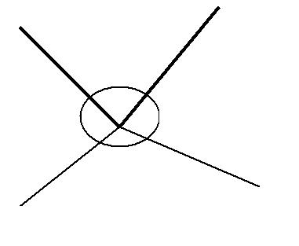

SKETCH:

O

D C

PROCEDURE:

If it is required to measure angles AOB, BOC, and COD etc by reiteration method

The following steps are to be used.

- Set the instrument over “O” and level it set the Vernier to zero and bisect point A accurately.

- Loose the upper clamp and turn the Telescope clockwise to point B. Bisect B by using the upper tangent screw. Read both the Verniers, the mean of the Verniers will give the angles AOB.

- Similarly, bisect successively C, D etc, thus closing the circle. Read both the Verniers at each bisection.
- Finally sight to A the reading of the vernier should be the same as the original setting reading.

Repeat the steps 02 to 04 with other face i.e. face Right.

Tabular Form

 | Averagehorizontal |  | angle
 | Horizontal Angle
 |  |  | Mean
FACE: RIGHT | SWING: LEFT |  | A Bangle
 |  |  | Horizontal
LEFT | RIGHT |  | Mean
FACE:SWING: |  |  | B
 |  |  | A

“ Sec ‘ Min
.o Deg. “ Sec ‘ Min

.o Deg.

“ Sec ‘ Min

.o Deg.

“ Sec ‘ Min “ Sec ‘ Min

.o Deg. “ Sec ‘ Min

.o Deg.

“ Sec

‘ Min

.o Deg. “ Sec ‘ Min “ Sec ‘ Min

.o Deg.

Sighted to

Instrumented to

EXPERIMENT NO. 17

MESUREMENT OF VERTICAL ANGLES

SURVEYING LAB DATE :

OBJECTIVE : To measure the Vertical angle of an object with respect to instrument station or any other point.
EQUIPMENTS : Theodolite and stand.

THEORY: A vertical angle is the angle between the inclined line of sight and the horizontal.

PROCEDURE:

To measure the Vertical angle of an object A at a station “O”.

- Set up the instrument over ‘O’ and level it with reference to the altitude bubble.

- Set the zero of the vertical vernier exactly to the zero of the vertical circle by Means of the vertical circle clamp and tangent screw.

- Bring the bubble of the altitude level to the center of its run. The line of Collimation is thus made horizontal, while the vernier reads zero.

- Loosen the vertical circle clamp, direct the telescope towards the object ‘A’, and sighted approximately, clamp the vertical circle and bisect ‘A’ exactly by turning the tangent screw.

- Road both venires. The mean of the two, readings gives the value of the required angle.

- Change the face of the instrument and repeat the process. The mean of the two vernier readings gives the second value of the required angle.

To measure the vertical angle between the two points A and B

- Bisect ‘A’ as before and note the readings on the vertical circle.

- Similarly, bisect ‘B’ and note the readings on the vertical circle.

- The sum or difference of these readings will give the value of the angle between A & B as one of the points is above and the other below the horizontal plane.
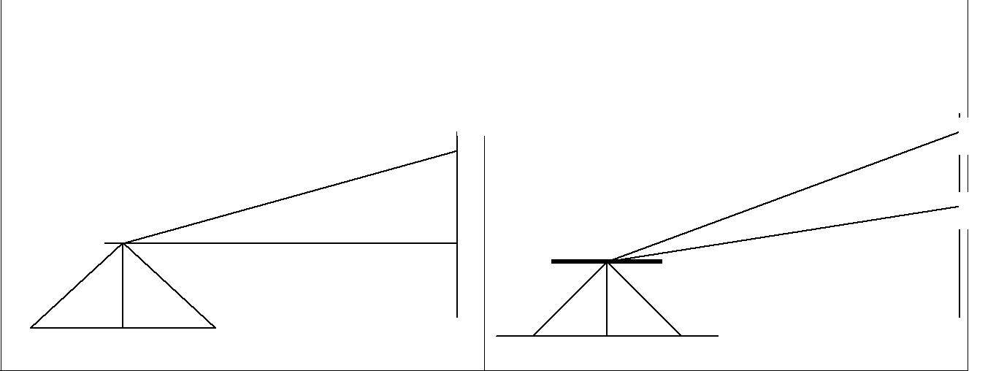  Figure 01 | Figure 02

A | A
 | B

Figure 03
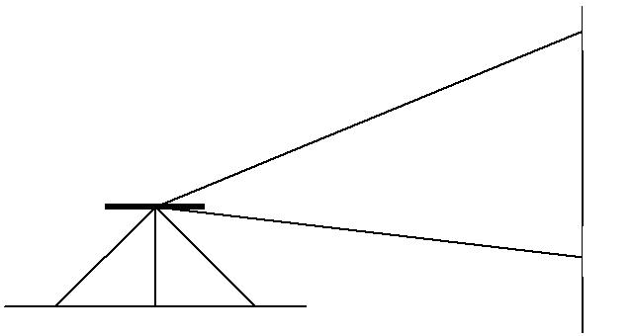
A

INSTRUMENTSTATION | SIGHT TO

α

B

OBS E R V A T I O N S

 |  | FACE LEFT |  |  |  |  |  | FACE RIGHT
 |  |  |  |  |  |  |  |  |  |  |  |  | AVERAGEVALUE
‘C’ SCALE |  |  |  | ‘D’ SCALE |  |  | ‘C’ SCALE |  |  | ‘D’ SCALE |  |  | AVERAGEVALUE
Deg | Min |  | Sec | Deg | Min | Sec | Deg | Min | Sec | Deg | Min | Sec | AVERAGEVALUE

RESULT: The observed vertical angle = _____

*** *** ***

EXPERIMENT NO. 18

DETERMINING DISTANCE BETWEEN TWO INACCESSIBLE PONTS BY MEASURING HORIZONTAL ANGLE

SURVEYING LAB DATE :

OBJECTIVE: Determining distance between two inaccessible points by measuring horizontal angle

EQUIPMENTS:

- Theodolite

- Chain / Tape

- Ranging rods

- Plumb bob

- Stand
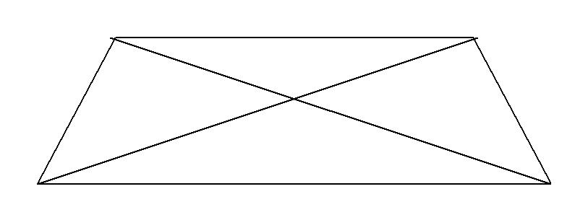
B
SKETCH: A

D

PROCEDURE:

C

- Select a base line CD and measure CD accurately.

- Setup the theodolite at C and level it accurately.

- Measure the horizontal angles DCA and ACB each on both faces of the instrument and take their respective mean values.

- Observe horizontal angles ADB and BDC on both faces and take the mean values of each.
- Using the angles DCA, ACB, ADB and BDC of the distance, the required distance AB can be calculated.

- The Horizontal distance can also be calculated by plotting the angles and obtaining the intersection points A and B.

EXPERIMENT NO. 19

DETERMINING AN HEIGHT OF OBJECT BY MEASURING

VERTICAL ANGLE

SURVEYING LAB DATE:

OBJECTIVE: Determining a height of object by measuring vertical angle.

EQUIPMENTS :

- Theodolite

- Leveling Stop

3. Tape or Chain | Q1
- Pegs

- Plumb bob
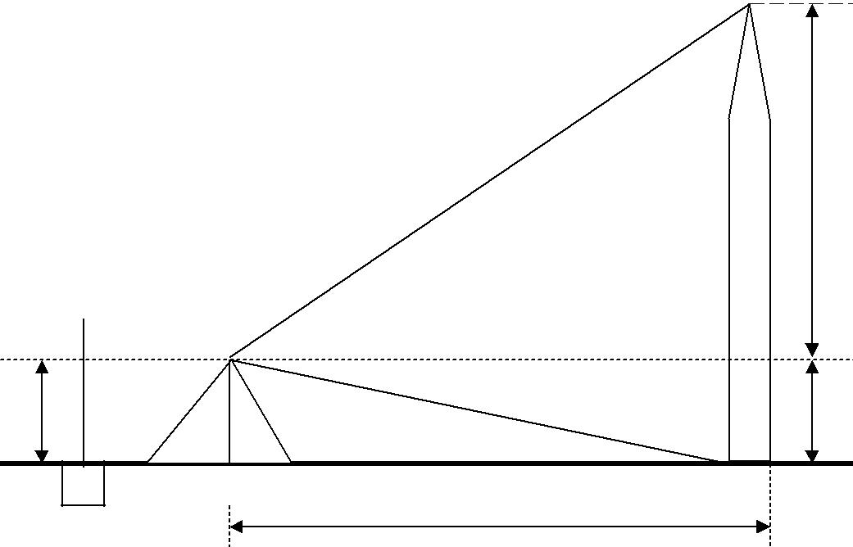
SKETCH:

 | α1 | Q2
 | α2
S
P | D | Q
PROCEDURE:
- Setup the instrument at station P.

- Perform all temporary adjustments.

- Bring the line of collimation horizontal

- Enter the initial readings in the tabular form.

- Swing the telescope and take staff reading over the given B.M.

- Swing the telescope towards the object.

- Release the vertical clamp screw, sight the top of the object Q1, and clamp the vertical clamp screw.

- Read C and D verniers and enter the readings.

- Release the vertical clamp screw, sight the bottom of the object Q, and clamp the screw.

- Read vernier readings and enter in the tabular form.

- Measure the Horizontal distance between the instrument station and the object.

- The above procedure will be repeated with the face right observation.

- The average of the two observations by transiting the telescope taken with different faces will be vertical angle.

- Calculate the height of the top point Q₁ from horizontal line (h₁) and height of the bottom point Q₀ from horizontal line (h₂) by using formula h = d tan α
OBS E R V A T I O N S

FACE: RIGHT

FACE: LEFT

Average | Verticalangle |  | “ Sec
Average |  |  | ‘ Min
Average |  |  | .o Deg.
VerticalAngle |  |  | “ Sec
 |  |  | ‘ Min
 |  |  | .o Deg.
 |  | Mean | “ Sec
 |  | Mean | ‘ Min
 |  | Mean | .o Deg.
LEFT |  | D | “ Sec
LEFT |  | D | ‘ Min
LEFT |  |  | “ Sec
SWING: |  |  | “ Sec
SWING: |  | C | ‘ Min
SWING: |  |  | .o Deg.
 |  | Verticalangle | “ Sec
 |  | Verticalangle | ‘ Min
 |  | Verticalangle | .o Deg.
 |  | Mean | “ Sec
RIGHT |  | Mean | ‘ Min
RIGHT |  | Mean | .o Deg.
RIGHT |  |  | “ Sec
 |  |  | ‘ Min
SWING: |  | C D | “ Sec
SWING: |  | C D | ‘ Min
 |  |  | .o Deg.
Sighted to

Instrumented to

F o r m u l a :

h 1 | = | D T a n α1
h 2 | = | D T a n α2

.h = h1 + h2

TOPIC-6

PLOTTING

- Conventional signs in surveying.

- Plotting of a perpendicular and oblique offsets.

- Plotting of land survey – Chain & Cross staff surveying calculation of areas.
- Plotting of chain triangulation of small areas around building.

- Plotting of closed & Open traverse by compass surveying – Location of details.

  - ☺

Conventional signs in surveying

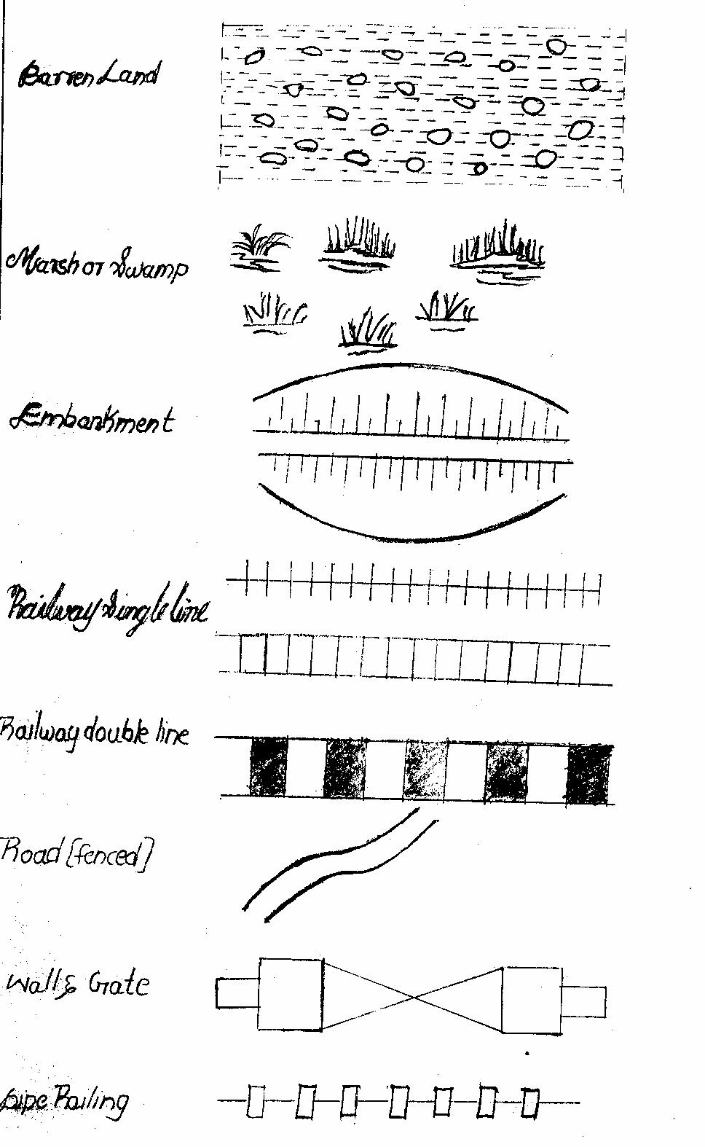

EXPERIMENT NO. 20

PLOTTING OF PERPENDICULAR AND OBLIQUE OFFSETS

SURVEY LAB: DATE:

OBJECTIVE: Plotting of perpendicular and oblique offsets.

INSTRUMENTS:

Metric Chain 20m / 30m | 1 | No. | Arrows | 10 Nos.
Ranging rods | 4 | Nos. | Cross | 1No
 |  |  | staff
Tape | 1 | No | staff

FIGURE:
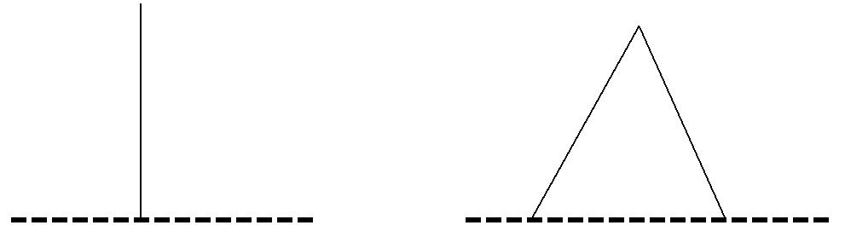

90 DEG.

PERPENDICULAR OFF SET OBLIQUE OFF SET

PROCEDURE:

- Run a chain line between the given station A and B

- Hold the cross staff vertically on the chain line where the perpendicular from the point “p” is expected to meet

- Turn the cross staff until one pair of opposite slit is directed to a ranging rod fixed at B (forward point)

- Look through the other pair of slits and see that the point ‘p’ bisect to which the offset is to be taken.

- If not, the cross staff is moved in forward or backward on the chain line AB until the line of sight bisects the point ‘p’.

- Measure the perpendicular offset distance PQ.

EXPERIMENT NO. 21

PLOTTING OF LAND SURVEY – CHAIN AND CROSS STAFF SURVEYING

CALCULATION OF AREAS

OBJECTIVE: Plotting of land survey – chain and cross staff surveying – calculation of areas.

INSTRUMENTS:

- Two Chains

- Arrows

3. | Ranging Rods |  |  |  |  | E
4. | Cross staff
5. | Plumb Bob | F
SKETCH:
 |  |  |  | 5
 |  |  |  | 5 |  | 4
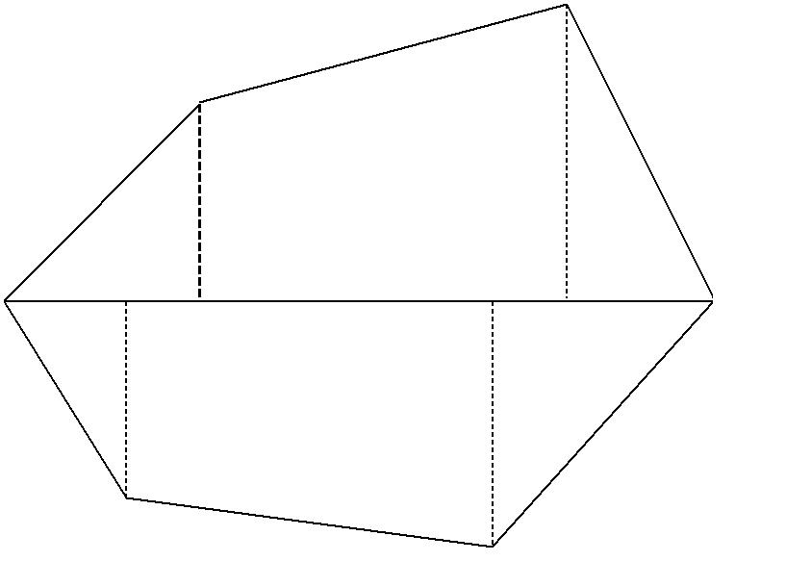
6

A

D

1

3

2

PROCEDURE: ^{B}

C

- Let A B C D E F be the given field whose area is to be measured.

- Divide the area into right-angled triangles and Trapezoids and measure their bases and perpendiculars.

- Two instruments are required

  - A cross staff to divide the area into triangles and trapezoids

  - A chain to measure lengths of base and perpendiculars.

- Calculate the area of triangles and Trapezoids.

- The sum of the areas of 1,2,3,4,5 and 6 gives the area of the given field. FORMULA: Area of the right angled triangle = ½ Base x Height
Area of Trapezoid = ½ ( a + b) h a, b are the parallel sides

h is the distance between the parallel sides.

EXPERIMENT NO. 21

PLOTTING OF CHAIN TRIANGULATION OF SMALL AREAS

AROUND THE BUILDING

SURVEYING LAB DATE :

OBJECTIVE: Plotting Of Chain Triangulation Of Small Areas Around The Building

INSTRUMENTS:
1. | Chain 20m / 30 m | - 1 No.
2. | Ranging rods | - 6 Nos.
3. | Arrows | - 10 Nos.
4. | Pegs | - 5 Nos.

PROCEDURE:

- Prepare key plans for layout of plots.

- Let A B C D E be the given field whose area is to be measured. Fix the pegs at A , B , C , D and E

- Divide the given area into three triangles ADE, ABD and BDC by joining AD and BD.

- Measure the lengths AB, CD, DE, EA and BD.

- Calculate the area of the triangles.

- The sum of the Three triangles is the area of the given field.

FORMULA:

Area of the Triangle = √ s (s-a) (s-b) (s-c)

Where a, b, c are the sides of triangle

S = (a + b + c) / 2

SKETCH:

D
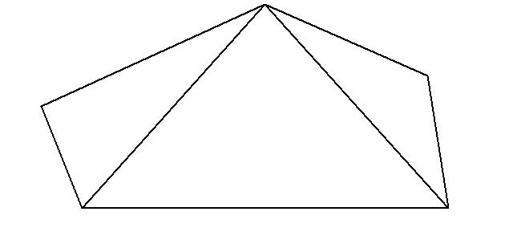

E C

A

B

PLOTTING OF CLOSED TRAVERSE BY COMPASS SURVEYING

LOCATION OF DETAILS

Draw a line indicating the magnetic meridian at A

Draw a line ‘AB’ at A to a suitable scale according to the measured distance and bearing of AB.

Draw a meridian at B parallel to the meridian at A and Draw ‘BC’ to the same scale according to the measured distance and bearing of BC.

Complete the transverse, by repeating the same procedure at all other stations.

* * * * * * * * * * * * * * * * * * * * * * * * * * * * * * * * * * * * *

PLOTTING OF OPEN TRAVERSE BY COMPASS SURVEYS

LOCATION OF DETAILS

Draw a line indicating magnetic meridian at ‘A’

Draw the line AB to a suitable scale from the measured distance and bearings.

Draw at ‘B’ a meridian parallel to the one, drawn at A.

From B knowing fore bearing and distance BC, draw the line BC. Similarly, draw all the remaining lines and complete the open traverse.

Check the accuracy by comparing the difference between F-B and B-B taken from 1st and last stations. If they differ by 180º the plotting is correct.

This type of survey is useful in roads, canals, and railways.

BTCE-309 WORKSHOP TRAINING

This will be held after 2nd Semester during summer in the Institute Workshop for four weeksdaily for 4 hrs. The students will be trained in the area of Carpentry, Electrical, Plumbing,Masonry and CAD work.

